ACADEMIC CONFIDENCE
Confidence or self-confidence - being an individual, personal attribute the terms are synonymous – is variously defined, but broadly can be considered as the extent of a belief about the potential for successfully getting something done. Confidence can be gained or lost through the experience-evaluation-feedback process and Stankov (2014) tells us that in considering confidence as a lens through which behaviour outcomes might be viewed, it explains most of the variance in achievement captured by the other ‘self’-constructs combined.
Rather than being regarded as a self-construct in its own right, confidence has been widely shown to be a sub-construct of self-efficacy, which is succinctly defined by Schunk (1984) as an individual’s personal judgements about their capabilities to organize and implement behaviours.
This paper looks at the roots of self-efficacy theory and the emergence of confidence in the context of academic behaviours, and explains how these ideas have formed part of the foundation of this research project exploring the impact of dyslexia on the academic confidence of university students.

Contents
OVERVIEW 3
KEY RESEARCH PERSPECTIVES: 7
Bandura – social cognitive theory, and the self-efficacy component of SCT in learning contexts 7
An overview of social cognitive theory 8
Self-efficacy in social cognitive theory and in learning 13
Dimensions of self-efficacy – level/magnitude, strength, generality 23
Task/domain specificity 26
Mediating processes 29
Agency 36
Other notable and influential researchers: Pajares, Schunk and Zimmerman 42
THE CONSTRUCT OF ACADEMIC SELF-EFFICACY 43
Relationship between academic self-efficacy and academic achievement 43
‘CONFIDENCE’ AS A LEARNING ATTRIBUTE 44
The location of academic confidence within the construct of academic self-efficacy 48
Academic confidence and learning differences 48
Measuring academic confidence – the emergence of an Academic Confidence Scale 49
ACADEMIC BEHAVIOURAL CONFIDENCE 49
Most recent research using the ABC Scale 60
Connecting Academic Behavioural Confidence to academic achievement 60
The ABC Scale in this research project 61
SUMMARY and CONCLUDING REMARKS 62
REFERENCES: 63

OVERVIEW
Confidence is a robust dimensional characteristic of individual differences (Stankov, 2012). Confidence can be considered as a sub-construct of self-efficacy where self-efficacy is concerned with an individual’s context specific beliefs about the capability to get something done (Bandura, 1995), and this is a core construct within the framework of social cognitive theory. Students who enter higher education or college with confidence in their academic abilities to perform well do perform significantly better than their less-confident peers. (Chemers et al, 2001). If individuals believe that they have no power to produce results then they will not attempt to make them happen (Bandura, 1997) and specifically, when students lack confidence in their capacity to tackle academic tasks they are less likely to engage positively with them (Pajares & Schunk, 2002). Academic confidence can be thought of as a mediating variable – that is, it acts bi-directionally – between individuals’ inherent abilities, their learning styles and opportunities presented in the environment of higher education (Sander & Sanders, 2003), and particularly when academic confidence is fostered as part of learning community initiatives it can be an important contributor to academic success (Allen & Bir, 2012).
Thus, confidence can be regarded as students’ beliefs that attaining a successful outcome to a task is likely to be the positive reward for an investment of worthwhile effort (Moller et al, 2005). Conversely, in those for whom confidence in their academic abilities is weak, these learners can interpret the accompanying anxiety related to academic performance as a marker of their incompetence which may be an incorrect attribution and which in turn may lead to exactly the fear of failure that has generated the anxiety (Usher & Pajares, 2008). Perceptions of capability and motivation, which include judgements of confidence, feature significantly in self-concept theories, in particular, social cognitive theory. This is where beliefs in personal efficacy are thought to be better predictors of academic outcomes than actual abilities or evidence from prior performance, because these beliefs are fundamental in establishing how learners are likely to tackle the acquisition of new knowledge and academic skills and how they will apply these productively, leading to positive and worthwhile outcomes (Pajares & Miller, 1995).
Social Cognitive Theory (SCT) enshrines these ideas and has been developed through decades of research and writing, particularly by Bandura (commencing: 1977) and other, subsequent theorists and researchers in psychology and educational psychology who have taken a similar perspective on the processes and rationales which drive the interactivity of humans with the environment and with each other. The underlying principle in social cognitive theory is that it is an attempt to provide explanations for the processes that drive and regulate human behaviour according to a model of emergent interactive agency (Bandura, 1986). This is a model which attributes the causes of human behaviour to multifactoral influences derived principally from the reciprocal interactions between inherent personal characteristics, the local and wider environment that surrounds the domain of behavioural functioning, and the behaviour itself. As such, considerable interest in SCT has been expressed by educationalists and education researchers seeking to apply and integrate the ideas enshrined in the theory into a clearer understanding of the functions of teaching and learning processes, especially for making these more effective mechanisms for the communicating of knowledge and the expression of ideas, and for interpreting the roots and causes of both academic failure and success.
Within this over-arching theory, the position of self-efficacy as a social psychological construct that relates self-belief to individual actions is a central and fundamental element. Self-belief is a component of personal identity and we might trace some of the roots of Bandura’s theories to earlier work on personal construct theory asserting that an individual’s behaviour is a function of not only the ways in which they perceive the world around them, but more particularly how they construct their world-view in such a way that enables them to navigate a path through it (Kelly, 1955). Along this route from Kelly to Bandura can be found the important, Rogersian ‘person-centred approach’ which takes as its focus the concept of the ‘actualizing tendency’ by which is meant the basic human processes that enable the accomplishment of our potential by developing our capacities to achieve outcomes (Rogers, 1959). We can see the embodiment of this in higher education contexts through institutions seeking to adopt a ‘student-centred’ learning environment where the aim is to shift the focus from a didactic curriculum presentation to systems of knowledge delivery and enquiry which is more co-operative and student self-managed, with varying degrees of success (O’Neill & McMahon, 2005).
These underpinning arguments and theses relating to human functioning have influenced the development of social cognitive theory by illuminating the mechanisms and processes that control and regulate the ways in which we behave and operate from a very different perspective to earlier arguments. Typically, those were based on either the psycho-analytic framework of Freud, or the strongly stimulus-response behaviourist principles proposed by Watson (1913), which attracted considerable interest from later psychologists eager to apply these to the learning process, perhaps the most notable being Skinner (eg: 1950), and which externalized behaviour to the exclusion of cognitive processes.

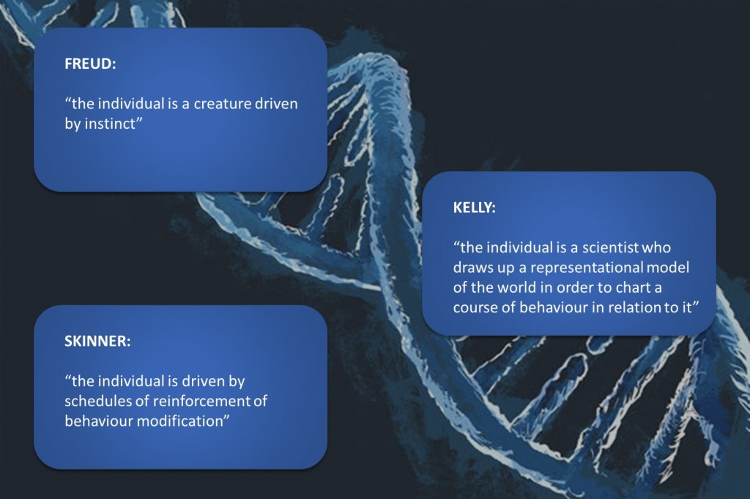
(adapted from Humphrey and Mullins, 2002)

Space and scope does not permit a full documentation of the historical development of all these competing theories in the narrative that follows, and so the focus will firstly be on exploring Social Cognitive Theory, as a highly influential late-twentieth century proposition that took a fairly radical new approach in its suggestions about how human behaviour is controlled and regulated by how we think, what influences these thought processes, and how these are transformed into consequential behavioural actions; and secondly, close attention will be paid to unpicking the somewhat elusive construct of academic confidence as viewed through the lens of the self-efficacy component of Social Cognitive Theory. Lastly, a research development of academic confidence, namely Academic Behavioural Confidence (Sander & Sanders, 2006), will be considered in terms of its roots in SCT, its linkages with academic self-efficacy, its development through numerous studies that have used it as the principal metric in their research and concluding with the specifics of how it has been used in this research project to explore the relationships between dyslexia and academic confidence in university students.

KEY RESEARCH PERSPECTIVES:

Bandura – social cognitive theory, and the self-efficacy component of SCT in learning contexts
In social cognitive theory (SCT), learning is considered as the process of knowledge acquisition through absorbing and thinking about information (Stajkovic & Luthans, 1998). The influence of Bandura’s original (1977) and subsequent work in developing social cognitive theory has had a major influence on education researchers because many of the components in SCT have been shown to significantly impact on understanding learning processes more clearly by adopting a more social construction of learning – that is, learning behaviour is considered, explored and theorized within the context of the environment where the learning takes place (Bredo, 1997). This is in contrast to behaviourist or experiential constructions, both of which have been popular at times and should be duly credited for their contribution to the ever-evolving field of the psychology of education and learning. Indeed the most recent ‘construction’ to explain learning claims greater pertinency in the so-called ‘digital age’ by arguing that all previous theories about learning are becoming outdated because they are all antecedent to the technological revolution that is now pervasive in most, more modern places of learning.

Briefly, this latest thesis is known as connectivism, (Siemens, 2005) and the idea is that the personal learning spaces of individuals now extend beyond conventional learning environments and places of study because informal learning is becoming a more significant construction in educative processes (ibid, p1) – that is for example, through communities of practice, social (learning) networks, open access to data and information repositories, work-based and experience-creditable learning and indeed, MOOCs. Significantly, connectivism is seen by some to be particularly influential in reshaping higher education for the future consumers of its products (Marais, 2011), into what is now being considered as a sociotechnical context of learning (Bell, 2011). However as with all emerging theories, critics argue that this new theory is unlikely to be the theory that explains how learning absorbs, transforms and creates knowledge, even in the new learning environments of e-learning (Goldie, 2016), because fresh ideas take time to be consolidated through critical evaluation and observation of practice, principally through research. Nonetheless, connectivism is winning advocates to its cause and may be highly attractive to learning providers where, in an uncertain financial climate, many of the costs associated with curriculum delivery are claimed to be significantly reduced (Moonen, 2001) albeit as a result of initial investment in developing and installing new technology systems.

An overview of social cognitive theory
The core of social cognitive theory is about explaining human behaviour in the context of systems of self-regulation. Bandura argues that these systems are the major influences that cause our actions and behaviours. Emanating from his earliest writings, the principal idea is enshrined by a model of triadic reciprocal causation where the three interacting factors of personal influences, the environment, and action-feedback-reaction mechanisms that are integrated into all human behaviours, act reciprocally and interactively as a structure that constitutes what is human agency – that is, the capacity for individuals to act independently and achieve outcomes through purposive behavioural actions. In this theory, individuals are neither entirely autonomous agents of their own behaviour nor are they solely actors in reactive actions that are driven by environmental influences (Bandura, 1989). More so, it is the interactions between the three factors that are thought to make a significant causal contribution to individuals’ motivations and actions. The graphic below illustrates the interrelationships between the three factors in the triadic reciprocal causation model and suggests many of the sub-components of each the factors:
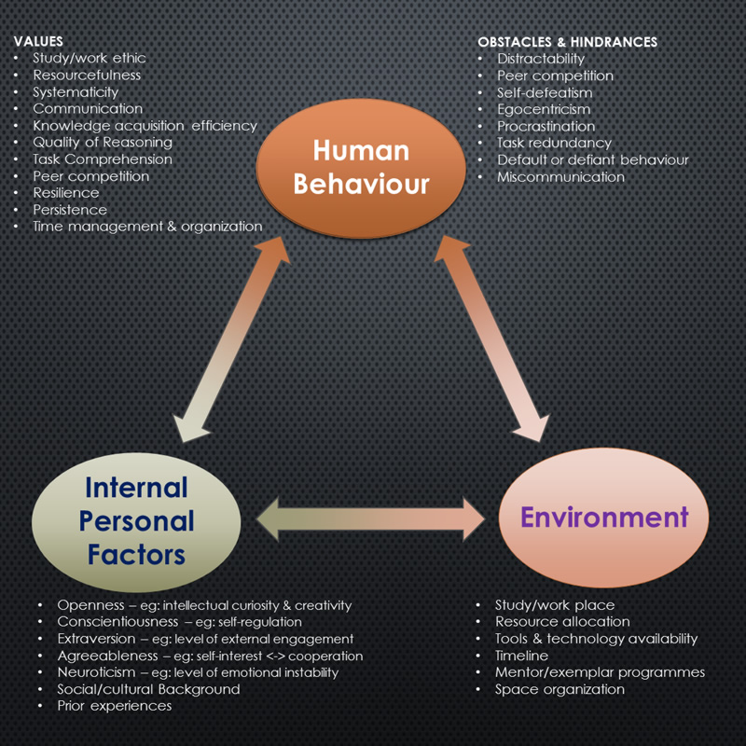
[adapted variously from Bandura, 1977, 1982, 1989, 1991, 1997]

Much of these systems of self-regulation are tied up with forethought based on past experiences and other influences – many of these being external – that precede purposive action. This is to say that within the context of belief-systems, goal-setting and motivation, we all plan courses of action through tasks and activities that are designed to result in outcomes. None of our actions nor behaviour is random, despite evidence in earlier theories to the contrary which appeared to have demonstrated that such random behaviours are externally modifiable through stimuli of one form or another (eg: Skinner, 1953) or as more casually observed through the apparently variable and unpredictable nature of human behaviour. By thinking about future events in the present, motivators, incentives and regulators of behaviour are developed and applied. Bandura constructs his theory of the self-regulative processes around three core concepts: that of self-observation, judgemental processes, and self-reaction. Although a linearity is implied, these concepts are more likely to operate in a cyclical, feedback loop so that future behaviour draws on lessons learned from experiences gained in the past, both directly and through more circuitous processes, as we will see below.
Key to self-observation is the self-reflective process: in order to influence our own motivations and actions we need to reflect on past performances. This is especially important in learning contexts and has been established as an important guiding principle in the blend of formal and independent learning processes that constitute the curriculum delivery at university in particular, where ‘reflective cycles’ are prevalent in numerous academic disciplines. This is especially so in ones that involve an element of practice development such as nursing and teaching (eg: Wilson, 1996, Pelliccione & Raison, 2009). But the self-diagnostic function can be very important per se, not least because for those who are able and motivated to respond to the information acquired by reflective self-monitoring, behavioural change and/or modification of the respective environment, the potential for improving learning quality can be a valuable outcome (Lew & Schmidt, 2011, Joseph, 2009). At university, this translates into students becoming more capable at making immediate and adaptive changes to their learning and study strategies to displace sometimes deeply entrenched surface- or ‘non-learning’ inertia and hence, change outcomes (Kinchin, 2008, Hay, 2007) and although may possibly lead to elements of academic dishonesty (Hei Wan et al, 2003), it is more likely that proactive learning innovations will bring higher academic rewards.
However, being self-judgemental can be challenging, especially when doing so has a bearing on perceptions of personal competence and self-esteem because affective reactions (that is, ones that are characterized by emotions) that may be activated can distort self-perceptions both at the time and also during later recollections of a behaviour (Bandura, 1993). But this does not alter the fact that observing one’s own pattern of behaviour is the first of a series of actions that can work towards changing it (ibid). First and foremost is making judgements about one’s own performance relative to standards, which can range from external assessment criteria to those collectively set by social and peer-group influences (Ryan, 2000) where the objective is to establish one’s personal standards with reference to the standards of the comparison group. Even within the framework of absolute standards that are set externally, social comparison has still been show to be a major factor that individuals refer to for judging their own performance although these judgements can vary depending on which social comparison network is chosen (Bandura & Jourden, 1991). This seems likely to be highly significant in education contexts and might be taken to indicate that teacher-tutor efforts at raising the achievement standards of individual students should also be applied to the student’s immediate learning-peer-group, the outcome of which would be shared improvement throughout the group which should carry with it the desired improvement of the individual.
But another significant factor that influences self-judgemental processes is the value that individuals attach to the activity that they are engaged in. Bandura (1991) tells us that, not unsurprisingly, individuals are less likely to engage positively with activities that they consider not important to them than with those that are viewed as valuable – for whatever reason – or which may have a significant impact on their futures. This is often challenging in compulsory education where adolescents in particular, tend to be very critical of the value of much of the curriculum learning that they are compelled to engage with (Thuen & Bru, 2000, Fabry, 2010). Not least this is because nationally-imposed curricula remain focused on conveying content to the detriment of developing thoughtful learners (Wiggins & McTighe, 2008), although some evidence shows that teachers who choose to adopt a more dialectic, rather than didactic approach to engaging with teenagers tend to be more successful in overcoming these teaching challenges (Cullingworth, 2014). A legacy of this reluctance to positively participate in learning structures, especially ones that adopt a conventional approach to the delivery of the curriculum, has been found to extend into tertiary level learning (Redfield, 2012) despite the greater degree of individualized self-learning management that exists in university learning structures where it would be expected that students who have chosen to study in a particular discipline are positively inclined to engage with it.
Performance judgements pave the way towards the last of Bandura’s three core components, that of self-reaction which, we learn, is the process by which standards regulate courses of action. This is about the way in which we integrate our personal standards into incentivisation or self-censure which is mostly driven by motivation levels based on accomplishment and the affective reactions to the degree to which success (or not) measures up to our internalized standards and expectations. In many domains of functioning there is abundant research to support the well-used cliché, ‘success breeds success’ with plenty of this in learning contexts: for example evidence has been found in university-industry learning-experience initiatives (Santoro, 2000), in mathematics teaching and learning (Smith, 2000), or in knowledge management and more business-oriented settings (Jennex, et al, 2009, Roth et al, 1994) with all of these studies reporting in one form or another, the positive impact of early- or first-initiative success on later-action success. Zimmerman (1989) reports that one of the most significant factors that differentiates between those who are successful in responding to their self-regulatory efforts and those who are not, is the effective utilization of self-incentives. We might imagine that this may be no-better illustrated than in the writing habits of PhD students who must depend on their own writing self-discipline because there is a much reduced supervisory element at this level of study in comparison to lower degrees. Hence developing writing incentives as part of the study-research process becomes instrumental to a successful outcome, with the most accomplished doctoral students likely to have developed the expected high-level study strategies early on. Indeed, there is now evidence to report that the process of ‘blogging’ as a means to provide writing incentives to university students is reaping positive benefits not least as online, personal study journals are likely to encourage extra-individual participation and self-reflection, and subsequently increase writing fluency (Zhang, 2009).
Thus the three-component structure of social cognitive theory has been briefly prequelled with particular attention being paid to its relationship to education and learning by providing examples about how the application of SCT might fit into learning and teaching contexts. But the functional operation of SCT now needs discussing and specifically, the construct of self-efficacy (and human self-efficacy beliefs) which is a key determiner that influences individuals’ choices about courses of action, how much effort they invest in them, their level of persistence and determination – especially in the face of adversity or setbacks – and the ways in which their thought patterns contribute positively or only serve to impede their progress.

Self-efficacy in social cognitive theory and in learning
Based on much of his earlier work developing Social Cognitive Theory, Bandura turned his attention to the application of SCT to learning. The seminal work on self-efficacy (Bandura, 1997) has underpinned a substantial body of subsequent research in the areas of behavioural psychology and social learning theory, especially in relation to the roles that self-efficacy plays in shaping our thoughts and actions in learning environments. Self-efficacy is all about the beliefs we have and the judgements we make about our personal capabilities and these are the core factors of human agency, where the power to originate actions for given purposes is the key feature (ibid, p3). Our self-efficacy beliefs contribute to the ways in which self-regulatory mechanisms control and influence our plans and actions, and hence, the outcomes that are the results of them. Bandura’s arguments and theses about how self-efficacy impacts on effort, motivation, goal-setting, task value, task interest and task enjoyment can be usefully distilled into 9 key points, additionally supported through the work of other researchers as cited. All of these points are highly pertinent in the domain of learning and teaching:
- Individuals with a strong self-efficacy belief will generally attribute task failures to a lack of effort whereas those with much lower levels of self-efficacy ascribe their lack of success to a lack of ability (Collins, 1982);
- Changes in self-efficacy beliefs have a mediating effect on the ways in which individuals offer explanations related to their motivation and performance attainments (Schunk & Gunn, 1986);
- Self-efficacy beliefs also mediate the ways in which social comparisons impact on performance attainments (Bandura & Jourden, 1991);
- Those who judge themselves to be more capable tend to set themselves higher goals and demonstrate greater commitment to remain focused on them (Locke & Latham, 1990);
- Self-doubters are easily deterred from persisting towards goals by difficulties, challenges and failures (Bandura, 1991);
- Conversely (to 5), self-assurance breeds an intensification of effort in the face of adversity or failure and brings with this, greater persistence towards success (Bandura & Cervone, 1986);
- Self-efficacy makes a strong contribution towards the ways in which individuals ascribe value to the things they attempt (Bandura, 1991);
- Individuals who present high levels of self-efficacy beliefs are more prone to remain interested in tasks or activities, especially ones from which they gain satisfaction by completing them and which enable them to master challenges (Bandura & Schunk, 1981);
- Deep immersion in, and enjoyment of pursuits and challenges tend to be best maintained when these tasks are aligned with one’s capability beliefs, especially when success contributes towards aspirations (Csikszentmihalyi, 1979, Malone, 1981);
Thus, self-efficacy is broadly about judging one’s capabilities to get something done and is integrated into many of the self-regulatory mechanisms that enable and facilitate the processes we need to engage in to accomplish things. That is, it is a construct that has functional characteristics and is a conduit for competencies and skills that enable positive outcomes. A function is a determinable mapping from one variable to a related dependent one, hence it is reasonable to suppose that outcome is a dependent function of self-efficacy, and that (academic) self-efficacy belief can be a dependent function of aptitude (Schunk, 1989). This idea now moves the discussion forward a little and might be illustrated in the context of a typical, university, academic example:
    - “Once I’ve got started on this essay about the role of mitochondria in cell energy factories I’m confident that I can make a pretty good job of it and finish it in time for the deadline”
This student is expressing a strong measure of self-efficacy belief in relation to this essay-writing task and we should notice that self-efficacy is domain (context) specific (eg: Wilson et al, 2007, Jungert et al, 2014, Uitto, 2014). Task and domain specificity is considered in more detail below. For our science student, the challenges of the task have been considered and the evaluation integrated with perceived capabilities – in this case, capabilities about writing an academic essay based on scientific knowledge. Whereas outcome can be more obviously considered as a function of self-efficacy, conversely, self-efficacy belief may also be a function of outcome expectations because the essay writing task has not yet commenced or at least certainly is not completed. The student is projecting a belief about how successful the outcome will be for some point in the future and so it is reasonable to suppose that this may have an impact on the ways in which the task is approached and accomplished. This is an important point, however the bidirectionality of the functional relationship between self-efficacy beliefs and outcome expectations is not altogether clear in Bandura’s writings. In an early paper it is argued that Social Cognitive Theory offers a distinction between efficacy expectations and outcome expectancy:
“An efficacy expectation is a judgement of one’s ability to execute a certain behaviour pattern, whereas an outcome expectation is a judgement of the likely consequences such behaviour will produce” (Bandura, 1978, p240).
By including the phrase ‘likely consequences‘ Bandura’s statement seems to be indicating that a self-efficacy belief precedes an outcome expectation and although these concepts seem quite similar they are not synonymous. For example, a student who presents a strong belief in her capacity to learn a foreign language (which is self-efficacy) may nevertheless doubt her ability to succeed (an outcome expectation) because it may be that her language class is frequently upset by disruptive peers (Schunk & Pajares, 2001) and this conforms to the correct sequential process implied in the statement above. The key idea according to Bandura and others such as Schunk and Pajares – who broadly take a similar standpoint to Bandura although acknowledge that the relationships between self-efficacy beliefs and outcome expectancy is far from straightforward – is that beliefs about the potential outcomes of a behaviour only become significant after the individual has formed a belief about their capability to execute the behaviour likely to be required to generate the outcomes (Shell et al, 1989) and that this is suggested to be a unidirectional process – that is, it can not occur the other way around. This is important because it implies that self-efficacy beliefs causally influence outcome expectancy rather than proposes a bidirectional, perhaps more associative relationship between the constructs, or that there are circumstances when they may be mutually influential. Bandura provides a useful practical analogy to argue the point that self-efficacy beliefs more generally precede outcome expectations:
“People do not judge that they will drown if they jump into deep water and then infer that they must be poor swimmers. Rather, people who judge themselves to be poor swimmers will visualize themselves drowning if they jump into deep water” (1997, p21).
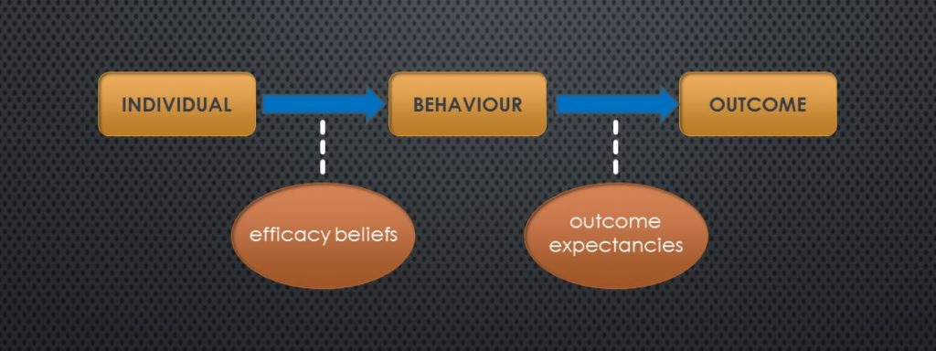
which is also demonstrated in a simple schematic presenting the conditional relationships between self-efficacy beliefs and outcome expectancies as Bandura sees it (adapted from 1997, p22):
However, a wider review of literature shows that the evidence is conflicting, to start with because definitions of construct parameters are not universally agreed. In trying to establish exactly what is meant by an individual’s self-efficacy beliefs, understanding is clouded because the key parameter of ‘capability’, widely used in research definitions, must be relative to the domain of interest but is also necessarily subjective, based on the individual’s perception of their capability in that context. Thus, even in an experiment with a clearly defined outcome that seeks to find out more about participants’ context-based self-efficacy beliefs and their task outcome expectancy, the variability between participating individuals’ perceptions of their capabilities, even in the same context, would be very difficult to control or objectively measure because these are ungradable, personal attributes formed through the incorporation of a diversity of individualized factors ranging from social, peer-group and family influences (Juang & Silvereisen, 2002) to academic feedback reinforcement which can be both positive and negative (Wilson & Lizzio, 2008).
Of the numerous studies found so far, ‘capability’ is almost universally used in an undefined way with the assumption made that its non-absolute variability is accommodated into the research methodology of the study on the basis of a tacit understanding about what it means. For example Bong, who has contributed substantially to the debate about the position of self-efficacy beliefs in learning situations, conducted several studies exploring academic self-efficacy judgements of adolescent and college learners. The general objectives were to reveal more about the context-specific versus generalized nature of the construct, or how personal factors such as gender or ethnicity affect self-efficacy judgements (Bong, 1997a, 1997b, 1998a, 1998b, 1998c, 2001, 2002), all of which relied on Bandura’s model as the underpinning theory to the research. In keeping with Bandura’s definitions of self-efficacy (previously cited) ‘capability’ was used throughout these studies, with perceived capability being specifically measured by gauging research participants’ judgments of their assuredness about solving academic tasks. But nowhere was to be found a meaningful definition of ‘capability’ with studies relying on readers’ understanding of ‘capability’, presumably contextualized into the nature of the research. To further illustrate the point that ‘capability’ should be not be left undefined, one other particularly interesting study provided some participants with a short contextual overview to aid their perception of ‘capability’ whereas others were not, and the research outcome subsequently showed that self-efficacy ratings were highly influenced by the way in which the notion of ‘capability’ was presented, or indeed, if not exemplified at all (Cahill et al, 2006). This appears to be a typical feature in the literature and is painting ‘capability’ as a kind of threshold concept (Meyer & Rand, 2003, Irvine & Carmichael, 2012, Walker, 2012) much like ‘irony’, where pinning down a meaning is elusive and rather, depends on the acquisition of a sense of the term through multiple, contextualized examples. Perhaps we have to live with this kind of definition uncertainty but it remains unsettling for the researcher because surely science prefers ground rules and definitions when scoping out and conducting research as opposed to building a study on a foundation of intangibles. An analogy might be the reliance on ‘similar case evidence’ such that the legal profession are known to employ to attempt to prosecute a case in the absence of facts and witness statements, which may as equally leave a jury uncomfortable in reaching a verdict as it might the scientist about the outcome of a study. Nevertheless, working with difficult-to-define concepts and constructs appears to be the status quo for research in the social sciences and in this study, working with ‘undefinables’ is one of the limitations that is important to identify.
Thus the literature shows that many researchers keen to exploit Bandura’s Social Cognitive Theory to support the design and methodologies of their studies may not have paid sufficient attention to this problem of operational definitioning by taking the theory ‘as read’ and without the adoption of a more objective standpoint or stating clearly their perspective. For example, Riggs et al (1994) applied the self-efficacy and outcome expectancy dimensions of SCT to find out more about attitudes to work in an occupational setting. Their study is a pertinent example of one that appears to be grounded in weak conceptual foundations, firstly because a reluctance to properly gain a grasp of the background understanding is perhaps evidenced because the evaluation scales developed were said to rely on ‘scrutin[y] by two “expert judges” with Ph.D degrees who had a knowledge of both measurement theory and Bandura’s theories‘ (ibid, p795); and secondly because the main focus of the study was to develop such evaluation scales based on the premise that self-efficacy and outcome expectancy are discrete constructs – which they cited as a central tenet of Bandura’s theory but without a discussion about Bandura’s key claim that self-efficacy beliefs unidirectionally influence outcome expectancy. In their scales, various characteristics of workers’ approaches to the demands of their occupations were supposedly determined – characteristics such as work satisfaction, organizational commitment and work performance – and although their scales were claimed to exhibit good reliability, any discussion about the likely, or at least possible, mutually influential interrelationships between self-efficacy and outcome expectancy was not evident, rather, offered an acknowledgement that the conclusion to the study remained disappointing and put this down to their results nevertheless being at least consistent with ‘the reality that performance is determined by many factors’ (ibid, p801). In the light of several earlier and contemporary studies which indicated that the causal unidirectionality was beginning to be challenged (see below) that had emerged between Bandura’s original thesis (1977) and Riggs’ research, it is a weakness in Riggs’ study for this not be considered as a factor which may have led to their ‘disappointing results’. Nevertheless, the four scales that their study developed, respectively measuring Personal Efficacy (PE), Personal Outcome Expectancy (POE), Collective Efficacy (CE) and Collective Outcome Expectancy (COE), do at least provide an insight into their interpretations of the interrelationships between self-efficacy and outcome expectancy in the context of an occupational setting (view the scales here) and their study’s factor analysis of the scales is claimed to support their understanding about Bandura’s early contention that self-efficacy beliefs and outcome expectancies are discrete constructs.
More disconcerting, is the evidence from several studies which appear to expose a deeper flaw in Bandura’s key argument, concisely summarized by Williams (2010), who seemed equally unsettled by the blind adoption of theory as fact rather than being guided by the spirit of scientific research based on nullius in verba. In his paper (ibid), a case was built through the examination and citation of several examples of research which countered Bandura’s ‘fact’ that self-efficacy beliefs causally influence outcome expectancies in that direction only. Williams summarizes an argument about the causality of self-efficacy beliefs on behaviour that has remained unresolved for three decades, particularly through use of extensive research by Kirsch amongst notable others, which explored the impacts that incentivizing outcome expectancy has on perceptions of capability, that is, self-efficacy beliefs. Williams re-ignited the debate on whether or not self-efficacy beliefs can be attributed as a cause for behaviour without being influenced by expectations of possible outcomes that will result from the behaviour, or even that the complete process can just as likely occur the other way around.
Kirsch’s (1982) bizarre studies involved enticing participants to approach a (harmless) snake in comparison to them engaging in a mundane and trivial skills exercise. The study clearly demonstrated that by using financial incentives, participants raised their levels of self-efficacy beliefs for both activities but more so for approaching the snake. This indicated that outcome expectancies can influence self-efficacy beliefs. Of particular interest in that research were the conclusions that efficacy ratings may take different values depending on whether they are in relation to non-aversive skills tasks or to tasks related to feared stimulus (ibid, p136). The key point is that for trivial or skills-based tasks, belief in an ability to accomplish them appears fairly fixed and not likely to be altered through incentivizing the tasks – individuals simply stick to the belief about what they are capable of – whereas tasks that are not reliant on a specific skill and particularly those which hold aversion characteristics, i.e. approaching a snake, individuals exhibit efficacy beliefs which can be modified through the offer of incentives because they are tasks that invoke (or not) willingness rather than ability. This is the significant point because ‘willingness’ is driven by an outcome expectancy whereas ability is driven by a self-efficacy belief. Hence Kirsh has shown that the causality linkage between self-efficacy beliefs and outcome expectancy is bidirectional in some circumstances. Similar findings were reported in other research domains, notably in relation to smoking cessation (Corcoran & Rutledge, 1989) and also where actual monetary gains were offered to induce college students to endure longer exposure to pain which, through the randomized nature of the actual rewards, showed that the impact of expected financial gain influenced self-efficacy (Baker & Kirsch, 1991). Indeed, Bandura’s interest in how efficacy beliefs are of a different flavour when associated with aversive or phobic behaviours is evidenced in studies in which his input is apparent, notably in domains which explore the impact on efficacy beliefs of therapeutic treatments proposed for the amelioration of such behaviours (eg: Bandura et al, 1982). Hence, it seems reasonable to suppose that similar relationships may occur in other domains. To put this into a more recent context in university learning, we might reflect on the increasing prevalence of incentivations that institutions are widely adopting to encourage attendance in the light of aversion to debt resulting from fees increases across the sector in the UK in the last decade. It is of note that the very socio-economic groups targeted by governments as desirable to encourage into university learning through widening participation initiatives, tend to be the most debt-averse and the least likely to have this aversion mediated through financial incentivization (Pennel & West, 2005, Bowers-Brown, 2006) – hence this may be one explanation for the continuing (albeit small) decline in student numbers in UK universities, especially for undergraduates and which is independent to demographic variations in cohort (UCAS, 2017). Indeed, Bandura tells us that ‘people who doubt they can cope effectively with potentially aversive situations approach them anxiously and conjure up possible injurious consequences‘ (1983, p464). For contemporary students, this may be the lasting legacy of substantial student debt and the consequences they perceive this may have on their later lives. Conversely, for those who anticipate an abilty to exercise control over their later financial circumstances and consider the benefits of higher education to outweigh the negative consequences of later debt, aversion towards high student fees and loans are mediated.
Hence we are left with two uncertainties when seeking to use the principles of self-efficacy beliefs to explain individuals’ behaviour: the first is that operational definitions of attributes and characteristics of self-efficacy are difficult to firmly establish, particularly the notion of ‘capability’; and secondly that Bandura’s underlying theory appears not quite as concrete as many researchers may have assumed and despite Bandura’s numerous papers persistently refuting challenges (eg: Bandura, 1983, 1984, 1995, 2007) it seems clear that care must be exercised in using the theory as the backbone of a study if the outcomes of the research are to be meaningfully interpreted in relation to their theoretical basis. In particular, there seems some inconsistency about the operational validity of the self-efficacy<->outcome expectancy relationship in some circumstances, notely ones that may involve attributing the functional relationships between the two constructs into phobic behaviour situations where self-efficacy measures of (cap)ability are obfuscated by the related but distinct construct of willingness (Cahill et al, 2006). Given elements of phobic behaviour observed and researched in the domain of education and learning (eg: school phobias; for some useful summaries see: Goldstein et al, 2003, King et al, 2001, Kearney et al, 2004), consideration of this facet of self-efficacy belief theory to learning contexts should not be neglected.
In summary, it is useful to compare the schematic above (taken from Bandura, 1997, p22) which illustrates the unidirectional relationship from self-efficacy to outcome expectancies with the the schematic here, modified into our context based on a prior adaption (Williams, 2010, p420) of Bandura’s writings in the same volume (op cit, p43) which apparently suggests that a reversed causality direction can occur.
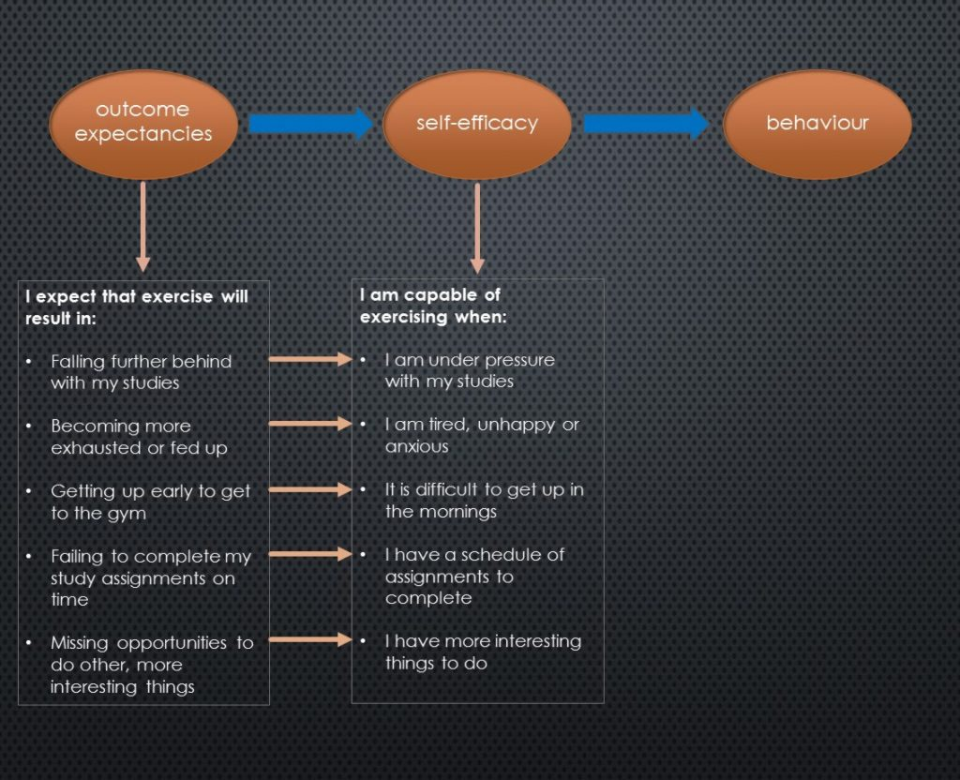
[more here required about Bandura’s response to these criticisms? If so use Bandura, 2012 (On the functional properties of perceived self-efficacy revisited) and 2015 (On deconstructing alternative theories of self-regulation) as the core]

Dimensions of self-efficacy – level/magnitude, strength, generality
Efficacy beliefs in the functional relationship that link self-efficacy through behaviour to outcome expectations (and sometimes reciprocally as we have discussed above) have been shown through a wide body of literature supporting Bandura’s central tenets to be componential and we can think of the level or magnitude of self-efficacy expectations and the strength of self-efficacy expectations as the two primary dimensions. (Stajkovic, 1998). Magnitude is about task difficulty and strength is the judgment about the magnitude: a strong self-efficacy expectation will present perseverance in the face of adversity whilst the converse, weak expectation is one that is easily questioned and especially doubted in the face of challenges that are thought of as difficult, (a sense established above in points 5 and 6). Bandura referred to magnitude and level synonymously and either term is widely found in the literature.
    - MAGNITUDE: ‘whether you believe that you are capable or not …’
    - STRENGTH: ‘how certain (confident) you are …’
The essay-writing example used earlier demonstrates an instance of the capacity to self-influence, and in learning challenges the ways in which an individual reacts to the challenges of an academic task is suggested to be a function of the self-efficacy beliefs that regulate motivation. It also provides an example of academic goal-setting – in this case, meeting the deadline – to which motivation, as another significant self-regulator mediated by self-efficacy, is a strong impacting factor, and to which significant associations between academic goal-setting and academic performance have been demonstrated (Travers et al, 2013, Morisano & Locke, 2012). However, expanding on this is for a later discussion although the graphic below serves to illustrate how the dimensions of magnitude and strength might be working in relation to the example-task of writing an academic essay. Each quadrant provides a suggestion about how a student might be thinking when approaching this essay-writing task and are related in terms of their levels of perceived capability (magnitude) and confidence (strength) as dimensions of their academic self-efficacy beliefs.
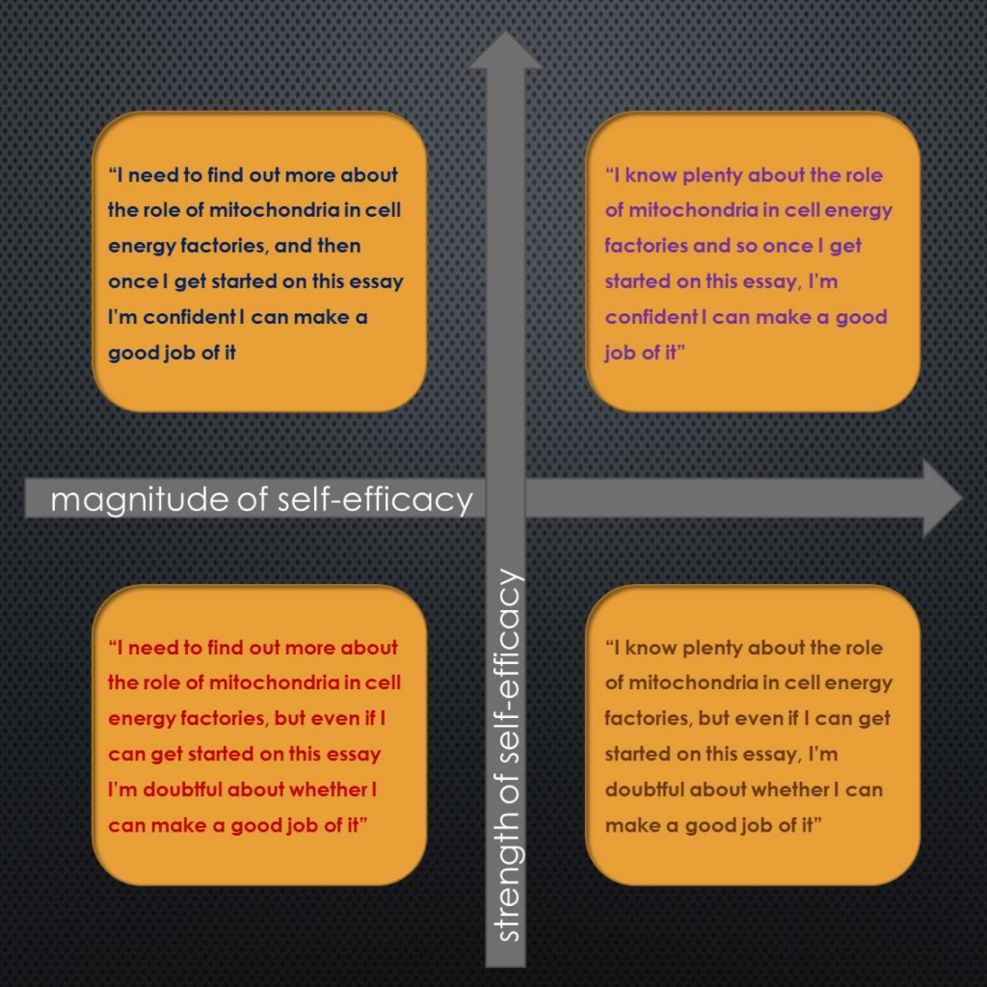
In his original paper (1977) Bandura set out the scope and self-efficacy dimensions of magnitude and strength, and also the third dimension, ‘generality’ which relates to how self-efficacy beliefs are contextually specific or more widely attributable. The paragraph in this paper which provides a broad overview is presented verbatim (below) because it is considered useful to observe how confounding this earliest exposition is, and hence to reflect on how Bandura’s original thesis may have confused subsequent researchers due to the interchangeability of terms, words and phrases that later had to be unpicked and more precisely pinned down:

‘Efficacy expectations vary on several dimensions that have important performance implications. They differ in magnitude. Thus when tasks are ordered in level of difficulty, the efficacy expectations of different individuals may be limited to the simpler tasks, extend to moderately difficult ones, or include even the most taxing performances. Efficacy expectations also differ in generality. Some experiences create circumscribed mastery expectations. Others instil a more generalized sense of efficacy that extends well beyond the specific treatment situation. In addition, expectancies vary in strength. Weak expectations are easily extinguishable by disconfirming experiences, whereas individuals who possess strong expectations of mastery will persevere in their coping efforts despite disconfirming experiences.’
Bandura, 1977, p194

As an aside to trying to gain a clearer understanding of the message about level, strength and generality, it is of note that in this earliest of his writings on his theme, Bandura somewhat offhandedly speaks of ‘expectations’ which, in the light of the points made earlier, would be discomfiting were it not for later, clearer theses which relate the term to outcomes, with ‘efficacy expectations‘ being subsequently referred to as ‘perceived self-efficacy’ and ‘self-efficacy beliefs‘ – altogether more comprehensible terms. Indeed, in a later paper (1982) the phrase ‘efficacy expectations’ occurred just once and was used in referring to changes in efficacy through vicarious experiences (more of this below). By the time of this paper, Bandura’s discursive focus had sharpened with the result that the ideas were less confusing for the researcher, easier to understand and more appropriately applicable.

Task/domain specificity
To follow through from our student facing a challenging essay-writing task it should be noted that self-efficacy is not necessarily a global construct and tends to be task-specific (Stakjovic, 1998). Our student may think herself perfectly capable in essay-writing, but consider that arguing the key points to peers through a group presentation quite beyond her. Taking another example outside the environment of learning and teaching: In the domain of entrepreneurship and risk-taking, the sub-construct of entrepreneurial self-efficacy (ESE) was proposed as part of the research hypothesis in a study to explore decision-making in relation to the opportunities or threats presented in test dilemmas. Results supported the idea of entrepreneurial self-efficacy as a relevant, task-specific construct by indicating that decision-making based on higher levels of ESE were more opportunistic and had a lower regard for outcome threat (Kreuger & Dickson, 1994). A later study, also using ESE, generated research results which, it was claimed, established entrepreneurial self-efficacy as a distinct characteristic of the entrepreneur in relation to individuals operating in other business or management sub-domains and that it could be conversely used to predict the likelihood of an individual being strong in the specific traits observed as part of the profile of successful entrepreneurs (Chen et al, 1998). In moving closer towards an educational domain, at least in terms of the research datapool, Rooney & Osipow (1992) further tested a ‘Task-Specific Occupational Self-Efficacy Scale’ (TSOSS), previously developed in an earlier study, using a sample of psychology and journalism undergraduates (n=201) to explore its applicability to career development and career decision-making. Underpinned by prior research which measured occupational or career self-efficacy, the outcomes of their study supported the task-specificity of self-efficacy although admitted the emergence of measurable differences between what they termed ‘general’ occupational self-efficacy and task-specific sub-components derived through their TSOSS. This was apparent through results from a datagroup which presented high self-efficacy for a particular general occupation but presented low self-efficacy in relation to some of the associated sub-tasks of that occupation – for example, some males in their sample believed that they could perform the occupation of social worker but not complete the sub-tasks associated with the domain of social work very effectively. Although these examples seem confounding, one aspect that emerges is that there appears to be a need to distinguish between a self-efficacy measure that is adopted to gauge self-efficacy beliefs in a general domain to those related to specific tasks within that domain. Hence our essay-writing student may present low self-efficacy beliefs related to the specific task of writing about the behaviour of mitochondria in cell energy factories, but be more effficacious when caused to reflect about studying more generally on her biological sciences course.
And so it is apparent that the self-efficacy component of Bandura’s Social Cognitive Theory has been tested in a variety of domains. Aside from those described above, it has been applied in university athletics to explore aspects of training commitment and motivation (Cunningham & Mahoney, 2004), in sport more generally in relation to competitive orientation and sport-confidence (eg: Martin & Gill, 1991), in music performance anxiety, (Sinden, 1999), in health studies to explore outcome expectations of diabetes management (eg: Iannotti et al, 2006), and investigating alcohol misuse in college students (Oei & Morawska, 2004) amongst a plethora of other study foci. However, the particular interest of this project is with self-efficacy in an educational context – academic self-efficacy – and this is discussed in more detail below.
Thus even though the wealth of research evidence supports the domain specificity of self-efficacy and indeed within that, elements of task-specificity, an element of generality is apparent and it is worth mentioning as a closing remark to this section that some researchers have persisted in attempting to take a more generalist viewpoint on self-efficacy. Schwarzer & Jerusalem (1995) developed a General Self-Efficacy Scale which attracted further development and spawned validation studies by the originators and others throughout the following two decades (eg: Bosscher & Smit, 1998, Chen et al, 2001, Schwarzer & Jerusalem, 2010). An example of how it has been used is demonstrated by an extensive, cross-domain and cross-cultural investigation which, through a meta-analytic validation study, claimed general self-efficacy to be a universal construct and that it could be used in conjunction with other psychological constructs meaningfully (Luszczynska et al, 2004), and an even more comprehensive meta-analysis using data from over 19,000 participants living in 25 countries which also suggested the globality of the underlying construct ( Scholz et al, 2002). Bandura has consistently doubted the veracity of research results which, he claims, misinterpret self-efficacy as a clear, narrow-in-scope construct and which hence try to justify the existence of a decontextualized global measure of self-efficacy, especially citing the lack of predictive (for behaviour) capability that is weak when using a global measure as opposed to a specifically-constructed, domain-related evaluation, and that this ‘trait’ view of self-efficacy is thin on explanations about how the range of diverse, specific self-efficacies are factor-loaded and integrated into a generalized whole (Bandura, 2012, 2015).

Mediating processes
An appealing characteristic of self-efficacy theory is that it is strongly influenced by an individual’s cognitive processing of their learning experiences (Goldfried & Robins, 1982) and so in the field of human functioning, but in particular in learning processes, Bandura’s underlying arguments that efficacy beliefs are core regulators of the way we interact and engage with learning opportunities and challenges are weighty and robust. His theories are supported by a plenty of research providing evidence that the process by which efficacy beliefs shape our learning is most strongly influenced by four, intervening agencies which he describes as ‘mediating processes‘, and which although may be of individual interest, are processes which operate mutually rather than in isolation (Bandura, 1997). In this context ‘mediating’ means where the action of a variable or variables affect, or have an impact on the processes that connect ourselves with our actions – in this case, our learning behaviour.
Diagram here?
Bandura (eg: 1997) distills these these mediating processes into four components:
    - cognitive processes – where efficacy, that is, the capacity or power to produce a desired effect or action, and personal beliefs in it, are significant in enhancing or undermining performance;
    - motivational processes – where in particular, that through integrating these with attribution theory, the focus of interest is with explaining causality. In this way, theoretical frameworks are constructed which can find reasons that set apart otherwise similarly placed individuals but who take different approaches to (learning) challenges: At one end of the spectrum is the individual who attributes success to their personal skills, expertise and capabilities, and failure principally to a lack of effort. This individual is more likely to accept the challenges of more difficult tasks and persist with them, even in the face of a lack of successful outcomes. Whereas at the other end is the individual who may be convinced that their success or failure is mainly due to circumstances outside their control and hence, generally believes there to be little point in pursuing difficult tasks where they perceive little chance of success.
    - affective processes – which are mainly concerned with the impacts of feelings and emotions in regulating (learning) behaviour. Significantly, emotional states such as anxiety, stress and depression have been shown to be strong affectors.
    - selective processes – where the interest is with how personal efficacy beliefs influence the types of ((social) learning) activities individuals choose to engage with and the reasons that underpin these choices.
However the most significant aspect of social cognitive theory when applied to a social construction of learning where academic self-efficacy is suggested to be one of the most important influential factors, are the four, principal sources of efficacy beliefs. Bandura (ibid) has identified these four source functions as: mastery experience; vicarious experience; verbal persuasion; and physiological states.
Mastery experience is about successes won by building upon positive experiences gained through tackling events or undertakings, whether these be practical or physical, theoretical or cerebral. That is, experience gained through actual performance. But building a sense of efficacy through mastery experience is not about just applying off-the-peg, ‘coached’ behaviours, it appears to rely on acquiring cognitive processing, behavioural and self-regulatory skills that can enable an effective course of action to be executed and self-managed throughout the duration of an activity or life-action. For example, experience gained in essay-writing at university that steadily wins better grades for the student is likely to increase beliefs of academic self-efficacy – in essay-writing at least – whereas failures will lower them especially if these failures occur during the early stages of study and do not result from a lack of effort or extenuating external circumstances; academic self-efficacy is widely regarded as domain specific in that it must be considered as relational to the criterial task (Pajares, 1996). However, although experience successes and failures are powerful inducers, Bandura reminds us that it is the cognitive processing of feedback and diagnostic information that is the strongest affector of self-efficacy rather than the performances per se (op cit, p81). This is because many other factors affect performance, especially in academic contexts, relying on a plethora of other judgements about capability, not least perceptions of task difficulty or from revisiting an historical catalogue of past successes and failures, and so personal judgements about self-efficacy are incremental and especially, inferential (Schunk, 1991).
However our essay-writing student will have also formed a judgement of their own capabilities in relation to others in the class. In contrast to the absolutism of an exam mark gained through an assessment process where answers are either correct or not, many academic activities are perceived as a gauge of the attainment of one individual in relation to that of similar others. The influence that this has on the individual is vicarious experience and it is about gaining a sense of capability formed through comparison with others engaged in the same or a similar activity. As such, a vicarious experience is an indirect one, and even though generally regarded as less influential than mastery experiences, the processing of comparative information that is the essential part of vicarious experience may still have a strong influence on efficacy beliefs, especially when learners are uncertain about their own abilities, for whatever reason (Pajares, et al, 2007). A key aspect of vicarious experience is the process of ‘modelling’ by which an individual externalizes the outcome of the comparative processing into actions and behaviour that are aligned with the immediate comparative peer group. Thus for students engaging in learning activities of which they have limited experience, their efficacy beliefs can be influenced by the ways in which they perceive their peers to have achieved outcomes when working on similar tasks (Hutchison et al, 2006). In a sense, this is a kind of quasi-norming process by which an individual uses social comparison inference to view the attainments of ‘similar others’ as a diagnostic of one’s own capabilities. Hence, viewing similar others perform successfully is likely to be a factor in elevating self-efficacy, as equally the converse is likely to depress it. An element of self-persuasion acts to convince the individual that when others are able to successfully complete a task then a similar success will be their reward too. The influence of vicarious experience has been particularly observed in studies concerning the learning behaviours of children where although ‘influential adults’ are of course, powerful models for signalling behaviours, when ability is a constraint the influences induced by comparison with similar peers can be more impacting (Schunk et al, 1987). It is also interesting to note that in line with points raised above about the impact of technology on the domain of learning and the functioning of learners, the influence of social media on learning behaviour is now becoming more recognized and researched, particularly where the vicarious experiences gained through widespread use of social media networks amongst communities of learners in relation to their learning may be having an impact on academic outcomes, both positive and negative (Unachukwu & Emenike, 2016, Collis & Moonen, 2008).
An individual’s self-efficacy can also be developed as a consequence of the verbal persuasion of significant others who are relational to them. Verbal persuasion in the form of genuine and realistic encouragement from someone who is considered credible and convincing is likely to have a significant positive impact (Wood & Bandura, 1989). There is plenty of research to support the influence on self-efficacy of verbal persuasion as one of the factors of social cognitive theory with examples coming from a range of disparate fields: In management and accountancy, a work-integrated learning programme to prepare accountancy under-graduates for employment specifically focused on verbal persuasion as a key, participatory component of the course as a mechanism for enhancing self-efficacy. ‘Significant others’ comprised accounting professionals and industry representatives and the outcomes of the metric used to assess self-efficacy ‘before’ and ‘after’ showed verbal persuasion to have had a significant impact on the increased levels of self-efficacy observed in the participants of the programme (n=35) (Subramaniam & Freudenberg, 2007). In teacher-training, the sense of teaching (self)-efficacy has been found to have a strong influence on teaching behaviour (not unsurprisingly) which is especially significant in student-teachers as they develop their classroom competencies and where encouragement gained from positive feedback and guidance from more experienced colleagues positively impacts on teaching practice confidence (Tschannen-Moran & Woolfolk Hoy, 2002, Oh, 2010). And not least in sport where there are a plethora of studies reporting the positive impact that verbal persuasion has on self-efficacy beliefs either through motivating ‘team talks’ presented by trainers or coaches (eg: Samson, 2014, Zagorska & Guszkowska, 2014) but also through actions of ‘self-talk’ although one interesting study reported that the greatest elevations of self-efficacy, collective efficacy and performance indicators were with individuals who practised self-talk verbal persuasion that took the group’s capabilities as the focus (Son et al, 2011).
(more content required here?)
Somatic study is an enquiry that focuses individuals’ awareness holistically and is inclusive of associated physical and emotional needs and where decisions are influenced and informed by an intrinsic wisdom (Eddy, 2011). We understand ‘soma’ to mean in relation to the complete living body and in the context of behavioural regulation, it means a process of doing and being. This is especially distinct from cognitive regulation of actions and decision-making – hence Eddy’s attribution of somatic enquiry to dance. The connection here to Bandura’s work is that in forming judgements about capabilities, individuals’ physiological and affective states are partially relied upon and Bandura proposes that whilst somatic indicators are more especially relevant in efficacy judgements about physical accomplishments – in physical exertion such as strenuous exercise for example, our corporeal state is the most significant gauge of achievement, (or not, depending on our level of fitness perhaps) and hence influences our predictive ability to forecast likely future capacity and potential for further improvement – the ways in which our physiology reacts to or anticipates situation-specific circumstances and how our emotions are interrelated with this are impacting factors on efficacy judgements. (Bandura, 1997).
Many early research studies exist which explore the impact of affective states on learning – that is, how we are feeling whilst we are learning – especially following the publication of Bandura’s original paper about factors that drive and control self-regulation (1977) which kindled interest in how emotion influences learning. However some studies appeared oblivious of the significance of Bandura’s work but are of interest because they present a slightly different perspective on how emotions and affective states impact on behaviour regulation. One interesting paper proposed a linkage system of ’emotion nodes’ that are each comprised of components that are connected to it by associative pointers such as autonomic reactions, verbal labels and expressive behaviours (Bower et al, 1981); the theory proposes that individuals’ memory patterns are likely to be more deeply engrained when ‘mood-congruency’ exists. For example, a literature student preparing for an exam may be more likely to be able to recall a significant quotation from Shakespeare’s ‘As You Like It’ if their affective state at the time of learning matches the mood expressed in the quotation.
It is clear to see how powerful this process might be in learning contexts, especially for exam revision, and could almost be interpreted as akin to Skinner’s conditioned-response theories of learning which gained such popular acclaim amongst contemporary educational psychologists and practitioners some decades since. More modern theories proposing means’ to enhance study skills continue to advocate the use of memory triggers as a highly effective technique for exam preparation, for example constructing hierarchical pattern systems or memory pyramids (Cottrell, 2013), and many are developments of study-principles rooted in the pre-technology age when assessment was more closely aligned with the effective recall of facts (Rowntree, 1998). Indeed, one of the most recent developments in relating affective states to learning and memory has resulted in an emotional prosthetic which, through a variety of ‘mood sensors’, it is claimed, allows users to reflect on their emotional states over a period of time (McDuff et al, 2012). This thesis originated in earlier work on multimodal affect recognition systems designed to predict student interest in learning environments (Kapoor & Picard, 2005), and hence connect emotions and mood to learning effectiveness. The ‘AffectAura’ product emerged out of this field of research and appears to have been available from the developers at Microsoft as a download for installation on a local PC or Mac, however no sign of its current availability has been found suggesting that it was a research project that was eventually deemed commercially unviable.
Bandura too was taken by the idea of ‘mood congruency’ to support the argument about how affective states are able to directly influence evaluative judgements, (1997, p112, referring to Schwartz & Clore, 1988). The most important idea is about how individuals use a perception of an emotional reaction to a task or activity rather than a recall of information about the activity itself as the mechanism through which an evaluation is formed. Hence, positive evaluations tend to be associated with ‘good moods’ and vice versa although it is the attribution of meaning to the associated affective state which can impart the greater impact on the evaluative judgement. For example, a student who is late for an exam may attribute increased heart rate and anxiety levels to their lateness rather than associate these feelings to prior concerns about performing well in the exam – which in this case could possibly be a positive contributor to the likelihood of the student gaining a better result! Of more significance is that where mood can be induced, as opposed to being temporally inherent, a respective positive or negative impact on efficacy beliefs can also be observed, indeed the greater the intensity of mood that is evoked, the more significant the impact on efficacy becomes: individuals induced to ‘feel good’ exhibit more positive perceptions towards task characteristics and claimed to feel more satisfied with their task outcomes (Kraiger et al, 1989) which implies enhanced efficacy beliefs. More interesting still, is that mood inducement is reported to have a more generalized effect on efficacy beliefs rather than be directly connected with the domain of functioning at the time of the mood inducement (Kavanagh & Bower, 1985) which is clearly highly relevant in teaching and learning environments.
Having said this, contradictory evidence does exist which suggests that in some situations, induced negative mood in fact increases standards for performance and judgements of performance capabilities because it lowers satisfaction with potential outcomes and hence, serves to raise standards (Cervone et al, 1994) – at least amongst the undergraduate students in that study. The argument proposed is that a consequence of negative mood was an evaluation that prospective outcomes would be lower and hence the level of performance that is judged as satisfactory, is raised, resulting in an outcome that is better than expected. In other words, make students miserable, they will try harder and hence get better results. A curious and surely dubious educational strategy to pursue. In any event, this, and other papers cited in this section are aligned with the idea of ‘affect-as-information’ the broad gist of which is that in general, individuals are more likely to more easily recall and focus on the positive aspects or outcomes of a task or activity when they are in a ‘good mood’ and equally more likely to experience the converse when their mood is more negative (Schwarz, 1989). In Bandura’s Social Cognitive Theory, the impact of affective state on perceived self-efficacy follows a similar contention: that success achieved under positive affectors engenders a higher level of perceived efficacy (1997).

Agency
In more recent writing, Bandura has taken an agentic perspective to develop social cognitive theory (Bandura, 2001) in which ‘agency’ is the embodiment of the essential characteristics of individuals’ sense of purpose. Sen (1993) argues that agency is rooted in the concept of capability, which is described as the power and freedoms that individuals possess to enjoy being who they are and to engage in actions that they value and have reason to value. Hence in adopting this perspective the notion of capability becomes more crystalized as a tangible concept rather than as an elusive threshold one, as outlined above. Cross-embedded with capability is autonomy with both being dimensions of individualism against which most indicators of agency have been shown to have strong correlations (Chirkov et al, 2003) in the field of self-determination theory (Ryan & Deci, 2000). Capability and, to a lesser extent, autonomy have been shown to be key characteristics for successful independent and self-managed learners (Liu & Hongxiu, 2009, Granic et al, 2009), especially in higher education contexts where the concepts have been enshrined as guiding principles in establishing universities’ aims and purpose, strongly endorsed by the Higher Education Academy some two decades ago (Stephenson, 1998). In this domain, Weaver (1982) laid down the early foundations of the ‘capability approach’ with strong arguments advocating the 6 Cs of capability – culture, comprehension, competence, communion, creativity, coping – that set to transform the nature and purpose of higher education away from the historically-grounded didactic transmission of knowledge to largely passive recipients through a kind of osmotic process, into the kind of interactive, student-centred university learning broadly observed throughout tertiary education today. Capable learners are creative as well as competent, they are adept at meta-learning, have high levels of self-efficacy and can adapt their capabilities to suit the familiar, varied or even unfamiliar activities, situations and circumstances in which they find themselves (Nagarajan & Prabhu, 2015).
In social cognitive theory, agency is where individuals produce experience as well as gain it, and as such shapes, regulates, configures or influences events that they engage in (Bandura 2000). It is viewed in terms of temporal factors embodying intentionality and forethought. These are deemed essential bases for planning, time-management and personal organization which are all elements of self-regulation that temper behaviour or are drivers of motivation in response to self-reactive influences. In particular, these are influences that guide or correct personal standards and foster introspective reflection about one’s capabilities and the quality of their application in the self-examination of one’s own functioning. Bandura advocates efficacy beliefs as the foundation of human agency (ibid, p10) and the most important idea is that three forms of agency are differentiated in social cognitive theory where each has a different influence on the behaviours and actions of individuals. Most of the theory and research centres around personal agency, with the focus being on how cognitive, emotional and affective processes, motivation, and choice all contribute towards shaping our actions. It is here that the key concept of self-efficacy belief is located, and, as outlined earlier, this construct is theorized as one of the drivers that influence our goals and aspirations, our feelings and emotions in relation to activities and behaviour, our outcome expectations and how we perceive and engage with difficulties, obstacles and opportunities encountered in our social sphere. In proxy agency, the second derivative of agency in social cognitive theory, the interest is with how individuals use influential ‘others’ to enable them to realise their outcome expectancies. This may be for one of three reasons: firstly, the individual does not consider that they have developed the means to reach the desired outcome; secondly, they believe that engaging someone to act on their behalf will see them more likely to achieve the outcome, or lastly, the individual does not want to, or does not feel able to take personal responsibility for direct control over the means to achieve the outcome. Proxy agency has been extensively observed in exercise research where numerous studies have evidenced the role of proxies in helping individuals manage the multiple self-regulatory behaviours that relate to continued adherence to exercise regimes (eg: Sheilds & Brawley, 2006,) and in industrial or institutional actions for example, where changes in work practices that impact on the workforce are negotiated or challenged by worker representatives or proxies (Ludwig, 2014).
Which leads neatly to the last form of agency, collective agency. Here, individuals act cohesively with a joint aim to achieve an outcome that is of benefit to all of them. This can be widely observed in the natural world where many animals work in swarms or in smaller groups together to strive towards a collective objective. In people, collective agency occurs extensively in group behaviour but most notably occurs in sport where it is a principle factor in effective team-working. Sometimes however, it can be observed that a collection of highly talented and skilled individuals – an example that comes to mind are some national football team in recent years – fail to bind together cohesively and cooperatively and hence, under-perform relative to both the individual expectations of the team members and indeed, their nations as a whole. Collective agency also occurs widely in the industrial or commercial workplace where unionized workforces collectively act towards, for example, improving working conditions and it can be seen that in this example in particular, a blend of proxy and collective agency operates to meet outcome expectancies. More pertinent to our domain of interest, collective agency is witnessed in schools where teachers’ beliefs in their own teaching efficacy have been noted to contribute to a collective agency in the institution which progresses the school as a whole (Goddard et al, 2000, Goddard et al, 2004a). Indeed, some studies have reported that high collective efficacy in schools can generate what has which in turn can impact positively on student achievement (Hoy, et al, 2006, Bevel & Mitchell, 2012). This has led to the emergence of fresh education research pioneered by Goddard (eg: 2001, Goddard et al, 2004b) and notable others (eg: Tschannen-Moran et al, 2004) leading to more recent interest in promoting learning and teaching regimes that adopt a more collaborative approach between teachers and students in the classroom to foster higher levels of academic achievement (Moolenaar et al, 2012). One, currently fashionable aspect of this new approach explores how the ‘flipped classroom’ can completely turn around the learning process to place students in positions of much greater control over the mechanisms that they may individually adopt to gain knowledge subsequently utilizing the expertise and guidance of their teachers or lecturers who create activities in the classroom that build on the academic material learnt independently. This is in sharp contrast to the conventional, passive approach typically characterized by the process of listening to a lecture followed by an out-of-class ‘homework’ assessment activity. Research evidence is emerging which appears to be indicating a mixture of advantages and pitfalls of flipped-classroom learning, not least because it is too early to judge the impact that this revolutionary change in learning ideology may have on student achievement but also because difficulties in operationalizing clear definitions of what is meant by ‘flipped classroom’ is obfuscating conclusions that might be drawn from research outcomes (Bishop & Verleger, 2013). However, what has also emerged from this field of exploring the impact of collective efficacy on learning and student achievement is the liklihood that a new construct has been identified, that of academic optimism, pioneered in early research by Hoy et al (2006) and which is gathering credence as a valuable measure that can identify linkages between collective efficacy and raised levels of student achievement in learning environments (McGuigan & Hoy, 2006, Smith & Hoy, 2007).
In keeping with the points raised above, Bandura (2001) summarizes the application of the agentic perspective of social cognitive theory to education and learning by drawing attention to 21st century developments in technology that have influenced all domains of learning. This has shifted the focus from educational development being determined by formal education structures and institutions (that is, schools, colleges and universities) to new learning structures where information and knowledge is literally ‘on demand’ and at a learner’s fingertips. By virtue of social cognitive theory attributing personal self-regulation to be a key determiner of behaviour, it is clear that in this new learning landscape, those who are more effective self-regulators are likely to be better at expanding their knowledge and cognitive competencies than those are not (Zimmerman, 1990). Bandura argues that the examining the brain physiology which is activated in order to enable learning is unlikely to guide educators significantly towards creating novel or challenging conditions of learning nor develop faculties of abstract thinking, nor how to encourage participation or incentivize attendance, nor how to become more skillful in accessing, processing and organizing information nor whether more effective learning is achieved cooperatively or independently (op cit, p19). Indeed, it has been left to other researchers, some who have collaborated with Bandura, to explore more sharply the impact of applying social cognitive theory to academic achievement. For example, a longitudinal study which commenced at about the same time as Bandura’s (2001) originative paper was published, used structural equation modelling in a scientifically robust methodology to examine the predictive nature of prosocial behaviour in children – that is, where prosocial actions included cooperating, sharing, helping and consoling – on the later academic achievement and peer relations of adolescents. The outcome, perhaps not unsurprisingly, was that prosocialness appeared to account for 35% of the variance in later academic achievement in contrast to antisocialness (broadly in the form of early aggression) which was found to have no significant effect on either academic achievement nor social preferences (Caprara et al, 2000).
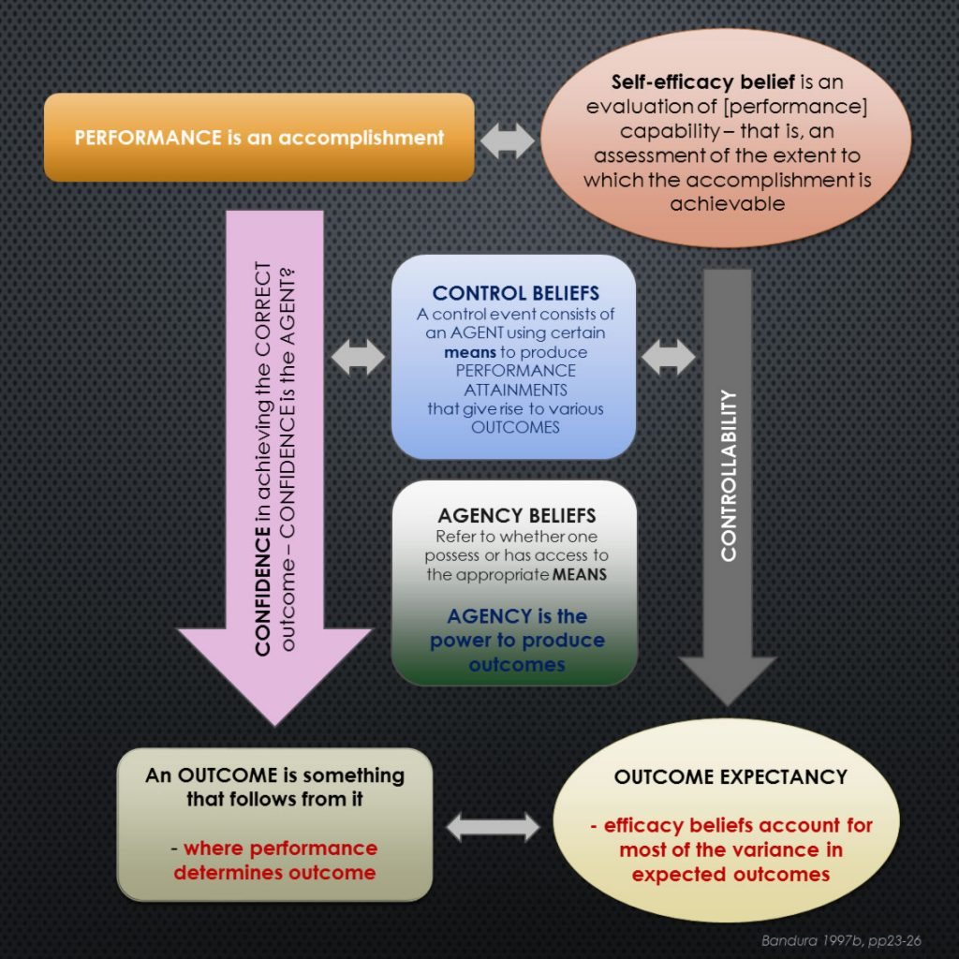
In conclusion, the graphic below attempts to draw from Bandura’s extensive writings to summarize the various components and factors which enable the processes which emanate from individuals’ self-efficacy beliefs to move them towards a behavioural outcome. The next sub-section reviews the contributions from other notable researchers to the educational aspect of social cognitive theory ahead of moving the discussion into the domain of academic self-efficacy and particularly academic confidence as a sub-construct of academic self-efficacy, locating the discussion into the context of this research project.

Other notable and influential researchers: Pajares, Schunk and Zimmerman
Bandura’s Social Cognitive Theory explains human behavior according to the principles of triadic reciprocal causation as briefly summarized above, and as we have seen, researchers from many fields have sought to apply the ideas to their domain of interest outcomes of which vary in their degrees of credibility appearing as much proportional to their understanding of the concepts as with the appropriateness of their research methodology or adherence to due scientific diligence.
Significantly however, the application of SCT in the realms of education and learning has attracted a substantial body of research with notable colleagues and collaborators of Bandura leading the field in the last two or three decades. In the discussion so far, attempts have been made to connect the theory to practice, particularly to educational practice as this is the primary focus of this research project and so at this point and in advance of looking in more detail at how aspects of social cognitive theory has underpinned the research methodology of this project, a brief summary of the research outcomes of particular students of SCT have impacted on education and learning.

[more content in preparation]

THE CONSTRUCT OF ACADEMIC SELF-EFFICACY
In social cognitive theory it is widely argued that there are three main routes through which self-efficacy beliefs impact on the cognitive development and academic accomplishment. First and foremost is are learners’ beliefs in their own capabilities to regulate their learning behaviour and activites to enable mastery of the academic demands that are set before them; secondly are the efficacy beliefs of teachers and educators about their capabilities to motivate, incentivize, induce and encourage their students to engage in productive learning activities; and lastly, institutions’ collective agency, sense of purpose and efficacy beliefs which create the most suitable learning environment to enable their students to flourish (Bandura, 2006).

[more content in preparation]

Relationship between academic self-efficacy and academic achievement
Higher levels of academic self-efficacy predict successful academic performance in college students (Feldman & Kubota, 2015).
[Insert HERE: more about ASE as a MEDIATING variable that acts between others in the academic domain]

‘CONFIDENCE’ AS A LEARNING ATTRIBUTE
In the period pre-1967 a search retrieval returned only 8 studies with the phrase ‘academic confidence’ anywhere in the text with none including the phrase in the title. Three of these were studies that were more concerned with proposals in 1960s for integrating learning communities in an otherwise racially segregated USA and referred to academic confidence only deprecatively. Of the other five, one was trying to understand more about the learning challenges faced by child ‘retardates’; a much earlier study focused on academic challenges faced by young asthmatics, and the others used the term in narratives that were otherwise unrelated to learning or education.
The summary table below shows the increase in published research studies since this time.
Date range: | – 1967 | 1968 – 1977 | 1978 – 1987 | 1978 – 1987 | 1998 – 2007 | 2008 – 2017
Criteria:
Number of papers retrieved, n, with “academic confidence” found in the title or anywhere in the text * : | 8 | 26 | 42 | 200 | 695 | 2240
Number of expected papers, N, based on exponential growth model: | 7 | 22 | 67 | 208 | 644 | 1996
* using GoogleScholar, search conducted 28 February 2017

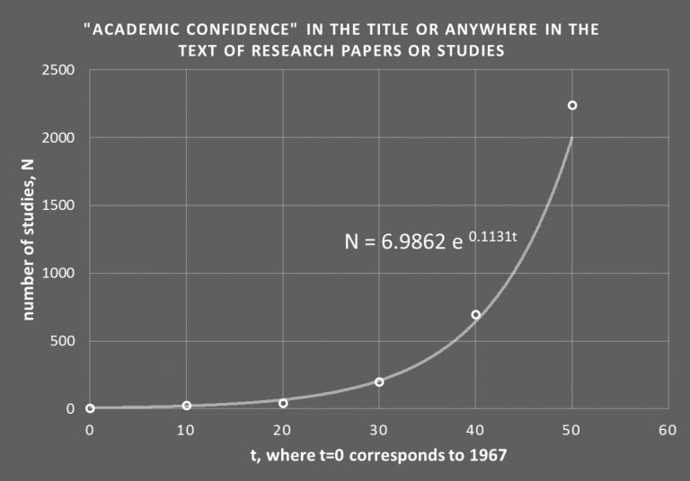
The number of actual items retrieved, n, from the search for each time-frame was plotted, and an exponential trendline generated in MS Excel was applied to the datapoints.

This generated the model equation shown in the graphic which was then used to generate the theoretical number of items that would be expected to be retrieved, N, using this exponential model.
As an illustration of real data demonstrating an exponential growth pattern, this is a clear example and may be indicative of the increasing recognition of academic confidence as a learning characteristic that can impact on the learning processes of individuals generally and academic achievement in particular. Or it may just be showing that the number of researchers has increased.
Either way, these data may be demonstrating a renewed interest in exploring learning processes in terms of new educational psychology that sought to relate non-cognitive functioning more closely to academic processes, previously thought of as largely unrelated as characteristics of learning.
However, other interesting results emerged in the first instance through use of the phrase ‘learning confidence’ in place of academic confidence, and secondly by combining each of these phrases in a Boolean search with ‘academic achievement‘. The table below collects all the search output results together for comparison

Date range: | -1967 | 1968-1977 | 1978-1987 | 1988-1997 | 1998-2007 | 2008-2017
Criteria: “ ~ “ | Number of papers, n, with “ ~ “ found in the title or anywhere in the text*
academic confidence | 8 | 26 | 42 | 200 | 695 | 2240
learning confidence | 15 | 9 | 60 | 105 | 537 | 1610
academic confidence AND academic achievement | 4 | 12 | 15 | 89 | 290 | 1160
learning confidence AND academic achivement | 0 | 1 | 6 | 12 | 69 | 266
* using GoogleScholar, search conducted 28 February 2017

It should be noted that this is the literature broadly available as returned according to search constraints applied and there is not the scope in this study to explore in detail the greater relevance of most of the output, setting aside of course, research that directly informs this project. However, a cursory inspection of the first few items returned in each search indicated that with the exception of studies where academic confidence, for example, was the primary focus of the research, the term tended to be used in a much more generally descriptive rather than evaluative way, or otherwise was measured using a relatively surface-based approach. For example, Hallinan (2008) was interested in the attitudes of school students to their school and how their perceived view about their teachers influenced this. Although the focus of the study was to explore ways to increase academic outcomes by improving students’ attraction to school, the attribute of academic confidence was only one of four variables used to do this and data was collected through acquiescence responses to just one statement: “I am certain I can master the skills taught in this class” (ibid, p276). Hallinan’s greater interest was in measuring clearly non-cognitive factors such as the extent to which students felt their teachers ‘cared’ about them, or how ‘fair’ they thought their teachers were. It was also apparent that the search output for the phrase ‘learning confidence‘ also returned results that included incidences where both were used as separate nouns rather than ‘learning‘ used in an adjectival form to describe the attribute of ‘confidence‘. Taking this into account suggests that the number of items returned using the phrase ‘learning confidence‘ may be an over-representation of the true number of papers which used the attribute in the way that ‘academic‘ is used to describe ‘confidence‘.
Thus there is a demonstrable increase in research interest in confidence as an attribute that can be attached to learning and academic progress. However it also seems apparent that much as in many research domains, not least those engendered in this research study, clearly defining a shared meaning to the term ‘attribute‘ can be problematic, especially so when specifically related to learning – that is ‘learning attributes’. Semantic differences can conflate research and my own practitioner experience in mathematics education has taught me that semantic clarity is key to early understanding – especially of concepts – and this has fostered a disposition towards visualization and iconography in designing and developing teaching resources to support my subject and more broadly as a mechanism for communicating ideas and expressing knowledge. The connection with this project is that preferences towards knowledge being presented visually is demonstrable in dyslexic learners, especially where interrelationships between concepts are complex and would otherwise require lengthy textual explanations to clearly present meaning. Not least this is sometimes due to a comorbidity of dyslexia with attention deficit disorder where the dyslexic reader may experience difficulty in isolating key ideas or be easily distracted from, or find increasing difficulty in engaging with the reading task (Goldfus, 2012, Garagouni-Areou & Solomonidou, 2004) or simply find reading exhausting (Cirocki, 2014). Dyslexic learners often get lost in the words. Thus drilling down to what is meant by ‘confidence‘ across the wealth of research literature on studies that include mention of it in an educational context requires a pragmatic approach and as for trying to pin down a definitive list of what constitutes learning attributes is best left for a another day. However the point is made.

As presented in the overview of this narrative, Stankov’s (2012) definition of confidence as ‘a robust characteristic of individual differences‘ works well. Since the late 1980s, Stankov has been publishing research exploring aspects of individual differences and how these impact on learning and education. Ranging from early papers exploring , for example, how training in problem-solving might expose differences in its effects on fluid- and general intelligence (Stankov & Chen, 1988) to a substantial body of more recent research that focuses on unpicking the wealth of data additional to academic achievement that is collected through triennial PISA (Programme for International Student Assessment) assessments. PISA is a battery of tests and questionnaires completed across OECD nations that assesses the skills and knowledge of a snapshot of 15-year-olds. PISA has been running since 2000 and in addition to assessing academic competencies, also collects data about other student characteristics such as their attitudes to learning and how the participants approach their studies from a non-cognitive perspective. One of Stankov’s most recent papers (2016) exploited the data reservoir of the latest, 2013 PISA survey, with the focus being on connecting the non-cognitive construct of self-belief to achievement in maths. The study draws on the premise that in addition to other non-cognitive variables (in particular, socio-economic status), self-beliefs are significant effectors of cognitive performance – that is, academic achievement – as either impediments in the form of anxiety, or facilitators where self-efficacy and confidence are the two major determiners.
[continue this theme; report on Stankov’s earlier paper specifically about CONFIDENCE as being the strongest non-cognitive predictor of achievement, but also link Stankov’s definition of confidence as pinned down in this 2016 paper (p12) to what confidence is, noting his cry for more work on the nature of confidence (p12). Link this to my rant above about the need for semantic clarity in the para above]

The location of academic confidence within the construct of academic self-efficacy
[content in preparation]

Academic confidence and learning differences
[content in preparation: use Klassen’s contribution to the debate not least about ‘the question of calibration’ which reviews the self-efficacy beliefs of students with LD – elsewhere on this blog; and in paper: ‘Too much confidence’ amongst others]

Measuring academic confidence – the emergence of an Academic Confidence Scale
In her doctoral dissertation, Decandia (2014) looked at relationships between academic identity and academic achievement in low-income urban adolescents in the USA. Although briefly reporting on the original Academic Confidence Scale developed by Sander & Sanders in 2003, her study chose to use neither that metric, nor the more recently developed version – the Academic Behavioural Confidence Scale (reported below) – but instead reverted to an Academic Confidence Scale originating in a near-twenty-year-old doctoral thesis (McCue-Herlihy, 1997), which she developed as ‘an organic measure of confidence in academic abilities’ (op cit, p44) for her study. This earlier thesis by McCue-Herlihy does not appear to have been published and thus is not available to consult although it is assumed, remains lodged in its home-university repository at the University of Maine. However this is of interest, as McCue-Herlihy’s Academic Confidence Scale appears to be the first time such a metric was constructed. In her study it seems it was created to contribute towards gauging self-efficacy academic achievement resource utilization and persistence in a group of non-traditional college students.
[more content in preparation]

ACADEMIC BEHAVIOURAL CONFIDENCE
Academic Behavioural Confidence is the key metric that is being used in this research project.
It is being applied as a comparator to the three research subgroups of interest: students with existing, identified dyslexia; students with no identified dyslexia but who present a dyslexia-like profile of study and learning attributes as indicated through the Dyslexia Index metric (developed for this project); and students with no previously identified dyslexia and who also present a very low incidence of dyslexia-like study and learning attributes.
As outlined above, academic confidence, through being a sub-construct of academic self-efficacy may also be linked to the academic outcomes and achievement of students at university. Hence measures obtained through the application of the Academic Behavioural Confidence Scale to the three, research subgroups are interesting even though no research evidence has been found to date to show that absolute scores of ABC are directly linked to absolute academic outcomes such as degree classification or grade point averages. It is suggested that a study to explore this is overdue.
However, by comparing ABC values between the three research groups of interest in this project, it will be clearly demonstrated that for this research datapool at least, the academic behavioural confidence of students with dyslexia is statistically lower than for non-dyselxic students but also lower than for students with unreported dyslexia-like profiles.
Historical development of the Academic Behavioural Confidence Scale
The ABC Scale is a development of an earlier metric used to explain the differences in students’ expectations in the teaching-and-learning environment of university (Sander et al, 2000). In that study, the research group comprised students from three disparate disciplines enrolled on courses at three different UK universities and the study emerged out of interest in the expectations of students following fresh thinking (at the time) in higher education about the increasing shift to consider students as ‘customers’ for university ‘products’ (Hill, 1995) – that is, more as consumers of the knowledge and learning that comprised the curriculum in a university course.
The student groups comprised medical students (n=167), business studies students (n=109) and psychology students (n=59) with the cohorts each studying at a different university. The questionnaire that was deployed interrogated students’ expectations of teaching and learning methods and respondents were requested to indicate their preferences. Aside from results and discussion that were specifically pertinent to this study, the construct of academic confidence was proposed as a possible explanation for significant differences in groups’ preferences in relation to role-play exercises and of peer-group presentations as approaches for delivering the respective curricula. In particular, the group of medical students and the group of psychology students both expressed strong negativity about both of these teaching approaches but it was the difference in reasons given that prompted interest: the medical students cited their views that neither of these teaching approaches were likely to be effective whereas the reasons given by the psychology students attributed their views about the ineffectiveness of both approaches more to their own lack of competence in participating in them. Sander et al suggested that these differences may have arisen as a result of academic confidence stemming from the different academic entry profiles of the two groups.
The idea of academic confidence was developed into the metric: Academic Confidence Scale (ACS) (Sander & Sanders, 2003), where academic confidence was conceptualized as enshrining differences in the extent to which students at university express strong belief, firm trust or sure expectation about what the university learning experience will be offering them. This implies that academic confidence is regarded as a less domain-specific construct than academic self-efficacy which is significant for the researcher as it enables the metric to be used more generally to explore attitudes and feelings towards study at university without these being focused on an academic discipline or specific academic competency – dealing with statistics, for example, or writing a good essay. Nevertheless, acknowledging academic confidence as a sub-construct of academic self-efficacy, this later study set out to explore the extent to which academic confidence might interact with learning styles or have an impact on academic achievement. Academic confidence was proposed to be a ‘mediating variable between an individual’s inherent abilities, their learning styles and the opportunities afforded by the academic environment of higher education’ (ibid, p4). In this later study two further groups of medical and psychology students were recruited (again at two different universities, n=182, n=102 respectively) although the aim of this research was to explore changes in academic confidence between two time-points in the students’ studies. The gist of the research outcome was first of all that academic confidence was moderated by academic performance rather than acted as a predictor, and secondly that these students at least, commenced their studies with unrealistic expectations about their academic performance that was tempered by actual academic assessment outcomes – perhaps unsurprisingly.
However, construct validity was established for the ACS and a preliminary factor analysis was also conducted although differences between the factor loadings for the two student groups led the researchers to conclude that analysis on a factor-by-factor basis would be inappropriate in this study at least. Although the 24 Likert-scale items remained unaltered, the ACS was renamed as the Academic Behavioural Confidence Scale some three years after its original development to more closely acknowledge the scale as a gauge of confidence in actions and plans in relation to academic study behaviour (Sander & Sanders, 2006b).
Subsequent research interest in the Academic Confidence Scale in the intervening period between its original development and its 2005 revision into the Academic Behavioural Confidence Scale was modest. Of the 18 studies found, these ranged from an exploration of music preferences amongst adolescents, relating these to personality dimensions and developmental issues (Schwartz & Fouts, 2003) which although included academic confidence as a metric in the data evaluation, it appears to have been derived from one of the 20 scales included in the Millon Adolescent Personality Inventory (Millon et al, 1982), implying that at the time of the study, the researchers were unaware of the recently developed Academic Confidence Scale; to a study exploring university students’ differences in attitudes towards online learning (Upton & Adams, 2005) which used the Academic Confidence Scale as one of a battery of 5 metrics in a longitudinal survey which aimed to gauge the impact of student engagement with an online health psychology module before and after the module was completed. The design focused on determining whether or not measures of academic confidence, self-efficacy and learning styles were predictors of performance on the module and hence which students would benefit most from this form of curriculum delivery. The study’s data analysis revealed no significant relationship between the variables measured and student engagement with the module from the 86 students included in the survey with the disappointed researchers claiming with hindsight that the lack of observable differences may have been attributed to an ill-advised research design and inappropriate choices of measures.
Lockhart (2004) conducted an interesting study about attrition amongst university students which was the first to explore the phenomenon using a sample of student drop-outs, acknowledging the range of difficulties that exist in contacting individuals who have already left their courses and to encourage their participation. As a result, the survey was small (n=30, in matched pairs of students remaining at, and students who had left university) but nevertheless a comprehensive battery of questionnaire items was used which were drawn from several sources, together with a programme of semi-structured interviews. The Academic Confidence Scale was incorporated into the research questionnaire with a view to exploring how different levels of confidence were related to student expectations of higher education. Care was taken to eliminate academic ability as a contributor to differences in academic confidence by matching pairs of participants for course subject and prior academic attainment. One of the research outcomes determined academic confidence to be a significant contributor to attrition, reporting that higher levels were recorded on the Academic Confidence Scale for participants remaining at university compared with those who had left their courses, although it was acknowledged that many other factors also had a strong influence on students’ likelihood of leaving university study early. Of these, social and academic integration into the learning community and homesickness in the early stages of study were cited as the most significant. However Lockhart’s results also appeared to indicate academic confidence to be a transitory characteristic which is affected by the most recent academic attainments – not unsurprisingly. This is consistent with the idea of academic confidence as a malleable characteristic, which had been suggested earlier through Sander’s original research and more strongly proposed in a later, summary paper (Sander et al, 2006a). In a study, similar to Lockhart’s, also into student retention and likelihood of course change, Duncan, (2006) integrated 5 items from the Academic Confidence Scale into the research questionnaire on the grounds that data obtained may offer insights into the mediating effect of academic confidence on the relationship between academic ability and academic integration, although no reasons for identifying these specific items from the full ACS as being particularly appropriate were offered. It is possible that the reason was simple expediency for reducing the questionnaire to a manageable size since, with a total of 151 Likert-style scale items, it is surprising that the researcher received data from a such a numerically robust sample (n=195) of final year university undergraduates although it is not known what percentage return rate this represents. In any event, results indicated academic confidence to be strongly positively correlated with the research hypothesis which was theorizing course-change or drop-out intention. The correlation outcome is presumably strongly positively correlated with the null hypothesis although this was not clearly indicated. It would be a highly unexpected result if it emerged that high levels of academic confidence were related to high levels of attrition!
A highly focused study used academic confidence in relation to the influences of assessment procedures on the confidence of teachers-in-training, in particular the use of video recordings of teaching sessions (White, 2006). A mixed-methods design appears to have been used which combined questionnaire items with semi-structured interviews with participants (n=68) who were all level 7 students (= Masters level (QAA, 2014)). The research objective was to explore whether video assessment processes would mitigate uncertainties about lesson planning and delivery and increase self-efficacy and confidence. The Academic Confidence Scale per se was not used but elements of it were imported into the data collection process. Results were not discretely related to the construct of academic confidence but were used to support a much more general use of the term ‘confidence’ in the context of teaching planning and delivery. Hence the research outcomes in relation to academic confidence as described by Sander were undetermined and again, it is possible that the availability of the Academic Confidence Scale was not known to the researcher at the time of the study.
Of the remaining 13 studies out of the 18 retrieved that included use of the Academic Confidence Scale, all were either conducted by Sander, usually in collaboration with others, or Sander appears to have been a contributing author. This collection of studies includes Sander’s own doctoral thesis (Sander, 2004) which explored the connections between academic confidence and student expectations of their university learning experience and built on the original project for which the Academic Confidence Scale was developed. The thesis comprised the author’s prior, published works which were all concerned with exploring students’ expectations and preferences towards teaching, learning and assessment at university. It was for this purpose that the Academic Confidence Scale was originally developed and subsequently used as the principal metric. These early studies increased confidence in the use of academic confidence to explain differences in students’ learning preferences with the findings providing evidence to argue for a greater understanding of students as learners (Sander, 2005a, Sander, 2005b) in order for learning in higher education settings to be more effective. This was pertinent in the university climate a decade or so ago which was witnessing student numbers increasing to record levels through a variety of initiatives, not least the emergence of widening participation as a social learning construct in education and the greater diversity of students that this and other new routes into higher education through foundation and access courses was bringing to the university community. With this, brought a greater attrition rate (eg: Fitzgibbon & Prior, 2003, Simpson, 2005) and so research attention on finding explanations for this was spawned.
The first of Sander’s studies to utilize the newly-named Academic Behavioural Confidence (ABC) Scale extended early research interest in the impact of engaging in peer-presentations on students’ confidence at university (Sander, 2006). As with earlier studies, the research was driven by a desire to find ways to improve university teaching by understanding more about students’ attitudes towards teaching processes commonly used to deliver the curriculum. Two broadly parallel participant groups were recruited (n=100, n=64 respectively) and all were psychology students, mostly female. The research aimed to determine whether significant differences in academic confidence could be measured depending on whether students were delivering non-assessed, compared with assessed presentations. Results indicated that despite the initial (and previously observed and reported (Sander et al, 2002, Sander et al, 2000)) reluctance of students to prepare and present their knowledge to their peers, beneficial effects on academic confidence of doing so were observed. Students typically reported these benefits to include experience gained in interacting with peers and hearing alternative perspectives about their learning objectives (op cit, p37). An interesting outcome from this study showed significant differences in post-presentation academic confidence attributed to whether the presentations were assessed or not assessed, with measurable gains in ABC being recorded following presentations that were assessed. Of particular interest in the discussion was an item-by-item analysis of ABC Scale statements suggesting this process as worthwhile for a better understanding of participant responses to be gained. This indicates that although ABC is designed to be a global measure of academic confidence, exploring specificity, as revealed by comparisons taken from items within the scale, can reveal greater detail about an academic confidence profile. Following their presentations, all participants in this study showed an increase in ABC items that related to public speaking.
A slightly later study explored gender differences in student attitudes towards the academic and the non-academic aspects of university life. Results from analysis of data collected using the ABC Scale showing that males gave a lower importance rating to their academic studies in relation to the non-academic side of being at university in comparison to females (Sander & Sanders, 2006b). Drawing on literature evidence arguing that females generally lack academic confidence and that males are more likely to rate their academic abilities more highly than female students, findings obtained through the ABC Scale questionnaire were, however, inconclusive with no overall differences in ABC between males and females being identified. This was explained as most likely due to the relatively small research group (n=72) and the strong female participant bias both in students enrolled on the course (psychology, females = 82.4%) and in the survey (80.6%) which it was suggested would have added a significant skew to the research outcome.
Pursuing a similar agenda, a slightly later study (Sander & Sanders, 2007) added to the earlier evidence (op cit) about noticeable gender-differences in attitudes to study revealed through use of the ABC Scale, which confirmed some previous findings about measurable differences in academic confidence between male and female undergraduates, but in this study, being observed particularly during their first year of university study. Key findings proposed that male students may be disadvantaging themselves due to a different orientation to their academic work which, it was suggested, compounded other issues faced by male psychology students through being in a significant minority in that discipline. Again, interesting individual-item differences were revealed showing, for example, that male students were significantly less likely to prepare for tutorials and also less likely to make the most of studying at university in comparison to their female peers both of which Sander’s regards as dimensions that impact on academic confidence. These findings were consolidated by returning to the same student group at a later date, hence creating a longitudinal study. Although students from both genders were included in the study, the research focused specifically on the academic confidence of male students (Sanders, et al, 2009). Once again, whilst there was little significant difference between ABC scores of males and females overall, detail differences on an item-by-item basis did emerge which were attributed to a measure of over-confidence in males’ expectation of academic achievement – especially in the first year of study. However the researchers noted that this perception was not displaced later, as actual academic achievement was comparable overall to that achieved by females and suggested that in this study at least, males saw themselves as able to achieve as good a result as females but with less work, with poorer organization and less engagement with teaching sessions.
Meanwhile, other studies using the Academic Behavioural Confidence Scale were beginning to emerge, possibly as a result of more widespread interest in a seminal paper presented by the original researchers (Sander & Sanders, 2006a) that summarized and consolidated their findings to date, which presented evidence of binding their theories about academic confidence and how it affected student learning and study behaviours more closely to the substantial body of existing research on academic self-efficacy, summarized briefly earlier. In this paper, useful comparisons between attributes of the related constructs of academic self-concept, academic self-efficacy and academic behavioural confidence were made, which drew on a lengthy comparative review (of the two former constructs) grounded in theories of academic motivation (Bong & Skaalvik 2003). The comparison table is reproduced here (below) as a useful summary of dimensions of all three constructs.
Having contextualized academic confidence and the ABC Scale particularly into social constructions of learning and teaching, it was suggested that the Scale could be best used to gain a deeper understanding of students' perceptions of themselves as learners and how this could be used to inform pedagogical research and practice in universities. Postulating that academic confidence emerges as a result of the same four roots of self-efficacy outlined earlier by Bandura - those of: mastery experience, vicarious experience, verbal persuasion, and physiological states (Bandura, 1997) as outlined above. However whilst the academic behavioural confidence scale is designed to gauge academic confidence globally, exploring attributes of academic confidence identified through responses to individual statements in the scale is considered as equally legitimate (op cit, p36), particularly where changes in confidence over time are the focus of a study. [more content in preparation]

Comparison dimension | Academic self-concept | Academic self-efficacy | Academic Behavioural Confidence
Working definition: | Knowledge and perceptions about oneself in achievement situations | Convictions for successfully performing given academic tasks at designated levels | Confidence in ability to engage in behaviour that might be required during a (student) academic career.
Central element: | Preceived competence | Perceived confidence | Confidence in abilities
Composition: | Cognitive and affective appraisal of self | Cognitive appraisal of self | Assessment of potential behavioural repertoire
Nature of competence evaluation: | Normative and ipsative* | Goal-referenced and normative | Response to situational demands
Judgement specificity: | Domain specific | Domain specific and context specific | Domain and narrowly context specific
Dimensionality: | Multidimensional | Multidimensional | Multidimensional
Structure: | Hierarchical | Loosly heirarchical | Flat and summative
Time orientation: | Past-oriented | Future-oriented | Future-oriented
Temporal stability: | Stable | Malleable | Malleable
Predictive outcomes: | Motivation, emotion and performance | Motivation, emotion, cognition and self-regulatory processes and performance | Motivation, coping, help-seeking and performance
 | *ipsative = comparison of 2+ choices, picking most preferred |  | (Sander & Sanders, 2006a, Table 1, p36; adapted from Bong & Skaalvik, 2003)

Most recent research using the ABC Scale
[content in preparation]

Connecting Academic Behavioural Confidence to academic achievement
Although Sander and corroborating researchers appear to have been principally interested in using academic behavioural confidence as a tool for exploring university students' interactions with university teaching and learning environments, specifically with a view to finding ways to make the learning experience more productive and effective and hence by implication more successful in terms of academic outcomes, there is a clear allusion to linking academic (behavioural) confidence and academic achievement more directly. Given the post-2006 renaming of the original Academic Confidence Scale into the Academic Behavioural Confidence Scale and the significant number of research studies published by Sander in the intervening 3 years, interest in using the ABC Scale as a metric for gauging the impact of non-cognitive learning attributes on academic performance has grown although the Scale remains relatively under-used.
However many researchers have identified academic confidence, often through its parent construct, academic self-efficacy, as a mediating variable that acts between others when trying to understand the relationships between the many variables that affect individuals' engagements with their learning domains.
Adeyemo (2007) measured emotional intelligence..
[more content in preparation]

The ABC Scale in this research project
[content in preparation]

SUMMARY and CONCLUDING REMARKS
[content in preparation]

REFERENCES:
Allen, D.F., Bir, B., 2012, Academic confidence and summer bridge learning communities: path analytic linkages to student persistence, Journal of College Student Retention, 13(4), 519-548.
Baker, S.L., Kirsch, I., 1991, Cognitive mediators of pain perception and tolerance, Journal of Personality and Social Psychology, 61(3), 504-510.
Bandura, A., 1977, Self-efficacy: towards a unifying theory of behavioural change. Psychological Review, 84(2), 191-215.
Bandura, A., 1978, Reflections on self-efficacy, Advances in Behavioral Research and Therapy, 1(4), 237-269.
Bandura, A., 1982, Self-efficacy mechanism in human agency, American Psychologist, 37(2), 122-147.
Bandura, A., 1983, Self-efficacy determinants of anticipated fears and calamities, Journal of Personality and Social Psychology, 45(2), 464-469.
Bandura, A., 1984, Recycling misconceptions of perceived self-efficacy, Cognitive Therapy and Research, 8(3), 231-255.
Bandura, A., 1986, Social foundations of thought and action: A social cognitive theory, Englewood Cliffs NJ, Prentice-Hall.
Bandura, A., 1989, Human agency in social cognitive theory, American Psychologist, 44(9), 1175-1184.
Bandura, A., 1991, Social cognitive theory of self-regulation, Organizational Behaviour and Human Decision Processes, 50(2), 248-286.
Bandura, A., 1995, Exercise of personal and collective efficacy in changing societies, IN: Bandura, A., (Ed), Self-efficacy in changing societies, Cambridge, Cambridge University Press.
Bandura, A., 1995, Comments on the crusade against the causal efficacy of human thought, Journal of Behaviour Therapy and Experimental Psychiatry, 26(3), 179-190.
Bandura, A., 1997, Self-efficacy - the exercise of control, New York, W.H.Freeman & Co.
Bandura, A., 2000, Exercise of human agency through collective efficacy, Current Directions in Psychological Science, 9(3), 75-78.
Bandura, A., 2001, Social cognitive theory: an agentic perspective, Annual Review of Psychology, 52, 1-26.
Bandura, A., 2006, Adolescent development from an agentic perspective, IN: Pajares, F., Urdan, T., Self-efficacy beliefs of adolescents, Greenwich CT, IAP.
Bandura, A., 2007, Much ado over a fault conception of perceived self-efficacy grounded in faulty experimentation, Journal of Social and Clinical Psychology, 26(6), 641-658.
Bandura, A., 2012, On the functional properties of perceived self-efficacy revisited, Journal of Management, 38(1), 9-44.
Bandura, A., 2015, On deconstructing commentaries regarding alternative theories of self-regulation, Journal of Management, 41(4), 1025-1044.
Bandura, A., Reese, L., Adams, N.E., 1982, Microanalysis of action and fear arousal as a function of differential levels of perceived self-efficacy, Journal of Personality and Social Psychology, 43(1), 5-21.
Bandura, A., Cervone, D., 1986, Differential engagement of self-reactive influences in cognitive motivation, Organizational Behavior and Human Decision Processes, 38(1), 92-113.
Bandura A., Jourden, F.J., 1991, Self-regulatory mechanisms governing the impact of social comparison on complex decision-making, Journal of Personality and Social Psychology, 60(6), 941-951.
Bandura, A., Schunk, D.H., Cultivating competence: self-efficacy and intrinsic interest through proximal self-motivation, Journal of Personality and Social Psychology, 41(3), 586-598.
Bell, F., 2011, Connectivism: its place in theory-informed research and innovation in technology-enabled learning, The International Review of Research in Open and Distributed Learning, 12(3), 98-118.
Bevel, R.K., Mitchell, R.M., 2012, The effects of academic optimism on elementary reading achievement, Journal of Educational Administration, 50(6), 773-787.
Bishop, J.L., Verleger, M.A., 2013, The flipped classroom: A survey of the research, ASEE National Conference Proceedings, Atlanta, GA, 30(9), 1-18.
Bong, M., 1997a, Congruence of measurement specificity on relations between academic self-efficacy, effort and achievement indices, Paper presented at the Annual Meeting of the American Educational Research Association, Chicago, IL.
Bong, M., 1997b, Generality of academic self-efficacy judgments: evidence of hierarchical relations, Journal of Educational Psychology, 89(4), 696-709.
Bong, M., 1998a, Personal factors affecting the generality of academic self-efficacy judgments: gender, ethnicity and relative expertise, Paper presented at the Annual Meeting of the American Educational Research Association, San Diego, CA.
Bong, M., 1998b, Tests of the Internal/External frames of reference model with subject-specific academic self-efficacy and frame-specific academic self-concepts, Journal of Educational Psychology, 90(1), 102-110.
Bong, M., 1999, Role of self-efficacy and task-value in predicting college students' course performance and future enrolment intentions, Paper presented at the Annual Convention of the American Psychological Association, Boston, MA.
Bong, M., 2001, Measuring self-efficacy: multi-trait multi-method comparison of scaling procedures, Paper presented at the Annual Meeting of the American Educational Research Association, Seattle, WA.
Bong, M., 2002, Stability and structure of self-efficacy, task-value and achievement goals and consistency of their relations across specific and general academic contexts and across the school year, Paper presented at the Annual Meeting of the American Educational Research Association, New Orleans, LA.
Bong, M., Skaalvik, E.M., 2003, Academic self-concept and self-efficacy: how different are they really? Educational Psychology Review, 15(1), 1-40.
Bosscher, R.J., Smit, J.H., 1998, Confirmatory factor analysis of the general self-efficacy scale, Behaviour Research and Therapy, 36(3), 339-343.
Bower, G.H., Gilligan, S.G., Monteiro, K.P., 1981, Selectivity of learning caused by affective states, Journal of Experimental Psychology: General, 110(4), 451-473.
Bowers-Brown, T., 2006, Widening participation in higher education amongst students from disadvantaged socio-economic groups, Tertiary Education and Management, 12(1), 59-74.
BredoE., 1997, The Social Construction of Learning, IN: Phye, G.D. (Ed), Handbook of Academic Learning, San Diego, Academic Press.
Cahill, S.P., Gallo, L.A., Lisman, S.A., Weinstein, A., 2006, Willing or able? The meanings of self-efficacy, Journal of Social and Clinical Psychology, 25(2), 196-209.
Caprara, G.V., Barbaranelli, C., Pastorelli, C., Bandura, A., Zimbardo, P.G., 2000, Prosocial foundations of children's academic achievement, Psychological Science, 11(4), 302-306.
Cervone, D., Kopp, D.A., Schaumann, L., Scott, W.D., 1994, Mood, self-efficacy and performance standards: Lower moods induce higher standards for performance, Journal of Personality and Social Psychology, 67(3), 499-512.
Cirocki, A., 2013, The reading portfolio: A tool for both learning and assessment in the secondary school EFL classroom, International Journal of Innovation in English Language Teaching and Research, 2(2), 223-228.
Chemers, M.M., Hu, L., Garcia, B.F., 2001, Academic self-efficacy and first-year college student performance and adjustment, Journal of Educational Psychology, 93(1), 55-94.
Chen, C.C., Greene, P.G., Crick, A., 1998, Does entrepreneurial self-efficacy distinguish entrepreneurs from managers? Journal of Business Venturing, 13(4), 295-316.
Chen, G., Gully, S.M., Eden, D., 2001, Validation of a new general self-efficacy scale, Organizational Research Methods, 4(1), 62-83.
Chirkov, V., Ryna, R.M., Kim, Y., Kaplan, U., 2003, Differentiating autonomy from individualism and independence: a self-determination theory perspective on internalization of cultural orientations and well-being, Journal of Personality and Social Psychology, 84(1), 97-110.
Collins, B.L., 1982, Self-efficacy and ability in achievement behaviour, Conference Paper presented at the Annual Meeting of the American Educational Research Association, New York.
Collis, B., Moonen, J., 2008, Web 2.0 tools and processes in higher education: quality perspectives, Educational Media International, 45(2), 93-106.
Cottrell, S., 2013, The Study Skills Handbook (4th edn), Basingstoke, Palgrave-Macmillan.
Csikszentmihalyi, M., 1979, Intrinsic rewards and emergent motivation, IN: Lepper, M.R., Greene, D (Eds), The hidden costs of reward, Morristown New Jersey, Erlbaum.
Cullingworth, E., 2014, Caring for adolescent students: a grounded theory study of teachers' perspectives on their relationships with students in secondary schools, unpublished post-graduate thesis, Simon Fraser University, BC Canada.
Cunningham, G., Mahoney, K., 2004, Self efficacy of part-time employees in university athletics: the influence of organizational commitment, valence of training and training motivation, Journal of Sport Management, 18(1), 59-73.
Decandia, G.M., 2014, Relationships between academic identity and academic achievement in low-income urban adolescents, unpublished doctoral thesis, State University of New Jersey.
Duncan, N., 2006, Predicting perceived likelihood of course change, return to university following withdrawal and degree completion, unpublished undergraduate dissertation, Glasgow University.
Eddy, M.H., 2011, Dance and somatic inquiry in studios and community dance programs, Journal of Dance Education, 2(4), 119-127.
Fabry, D.L., 2010, Combining research-based effective teacher characteristics with effective instructional strategies to influence pedagogy, Journal of Research in Innovative Teaching, 3(1), 24-32.
Feldman, D.B., Kubota, M., 2015, Hope, self-efficacy, optimism and academic achievement: distinguishing between constructs and levels of specificity in predicting college grade-point average, Learning and Individual Differences, 37, 210-216.
Fitzgibbon, C., Prior, J., 2003, Student expectations and university interventions - a timeline to aid undergraduate student retention, In: BEST Conference: Creativity and Innovation in Academic Practice, Brighton, April 2003.
Garagouni-Areou, F., Solomonidou, C., 2004, Towards the design of educational environments suitable to the needs of pupils with attention deficit hyperactive disorder (ADHD) symptoms, Proceedings of World Conference on Educational Multimedia, Hypermedia and Telecommunications 2004, Lugano, Switzerland, 4446-4451.
Goldfried, M.R., Robins, C., 1982, On the facilitation of self-efficacy, Cognitive therapy and research, 6(4), 361-379.
Goldie, J.G.S., 2016, Connectivism: A knowledge learning theory for the digital age? Medical Teacher, 38(10), 1064-1069.
Goldfus, C., 2012, Intervention through metacognitive development: A case study of a student with dyslexia and comordid attention deficit disorder, Journal of Languages and Culture, 3(3), 56-66.
Goldstein, J.S., Little, S.G., Akin-Little, A., 2003, Absenteeism: A review of the literature and school psychology's role, The California School Psychologist, 8, 127-139.
Goddard, R.D., Hoy, W.K., Hoy, A.W., 2000, Collective teacher efficacy: its meaning, measure and impact on student achievement, American Educational Research Journal, 37(2), 479-507.
Goddard, R.D., Hoy, W.K., Hoy, A.W., 2004a, Collective efficacy beliefs: theoretical developments, empirical evidence and future directions, Educational Researcher, 33(3), 3-13.
Goddard, R.D., LoGerfo, L., Hoy, W.K., 2004b, High school accountability: The role of perceived collective efficacy, Educational Policy, 18(3), 403-425.
Granic, A., Cukusic, M., Walker, R., 2009, m-Learning in a Europe-wide network of schools, Educational Media International, 46(3), 167-184.
Hallinan, M.T., 2008, Teacher influences on students' attachment to school, Sociology of Education, 81(3), 271-283.
Hay, D.B., 2007, Using concept mapping to measure deep, surface and non-learning outcomes, Studies in Higher Education, 32(1), 39-57.
Hei Wan, W.N., Davies, G., Bates, I., Avellone, M., 2003, Academic dishonesty among pharmacy students, Pharmacy Education, 3(4), 261-269.
Hill, F.M., 1995, Managing service quality in higher education: the role of the student as a primary consumer, Quality Assurance in Education , 3(3), 10-21.
Hoy, W.K., Tarter, C.J., Hoy, A.W., 2006, Academic optimism of schools: A force for student achievement, American Journal of Educational Research, 43(3), 425-446.
Hutchison, M.A., Follman, D.K., Sumpter, M., Bodner, G.M., 2006, Factors influencing the self-efficacy beliefs of first-year engineering students, Journal of Engineering Education. 18(1), 39-47.
Iannotti, R.J., Schneider, S., Nansel, T.R., Haynie, D.L., Plotnick, L.P., Clark, L.M., Sobel, D.O., Simons-Morton, B., 2006, Self-efficacy, outcome expectations and diabetes self-management in adolescents with Type I diabetes, Journal of Developmenatl & Behavioral Pediatrics, 27(2), 98-105.
Irvine, N., Carmichael, 2009, Threshold concepts: A point of focus for practitioners, Active Learning in Higher Education, 10(2), 103-119.
Jennex, M.E., Smolnik, S., Croasdell, D.T., 2009, Towards a consensus knowledge management success definition, Vine, 39(2), 174-188.
Joseph, N., 2009, Metacognition needed: teaching middle and high school students to develop strategic learning skills, Preventing School Failure: Alternative Education for Children and Youth, 54(2), 99-103.
Jungert, T., HEsser, H., Traff, U., 2014, Contrasting two models of academic self-efficacy: domain-specific versus cross-domain in children receiving and not receiving special instruction in mathematics, Scandanavian Journal of Psychology, 55(5), 440-447.
Kapoor, A., Picard, R., 2005, Multimodal affect recognition in learning environments, Proceedings of the 13th Annual ACM International Conference on Multimedia, 677-682, Singapore.
Kavanagh, D.J., Bower, G.H., 1985, Mood and self-efficacy: impact of joy and sadness on perceived capabilities, Cognitive Therapy and Research, 9(5), 507-525.
Kearney, C.A., Lemos, A., Silverman, J., 2004, The functional assessment of school refusal behavior, The Behavior Analyst Today, 5(2), 275-283.
Kelly, G.A., 1955, The Psychology of Personal Constructs, New York, Norton.
King, N.J., Heyne, D., Tonge, B., Gullone, E., Ollendick, T.H., 2001, School refusal: categorical diagnoses, functional analysis and treatment planning, Clinical Psychology & Psychotherapy, 8(5), 352-360.
Kinchin, I.M., Lygo-Baker, S., Hay, D.B., 2008, Universities as centres of non-learning, Studies in Higher Education, 33(1), 89-103.
Kirsch, I., 1982, Efficacy expectations or response predictions: The meaning of efficacy ratings as a function of task characteristics, Journal of Personality and Social Psychology, 42(1), 132-136.
Kraiger, K., Billings, R.S., Isen, A.M., 1989, The influence of positive affective states on task perceptions and satisfaction, Organizational Behavior and Human Decision Processes, 44(1), 12-25.
Krueger, N., Dickson, P.R., 1994, How believing in ourselves increases risk-taking: perceived self-efficacy and opportunity recognition, Decision Sciences, 25(3), 385-400.
Lew, M.D.N., Schmidt, H.G., 2011, Self-reflection and academic performance: Is there a relationship? Advances in Health Sciences Education, 16(4), 529-545.
Locke, E.A., Latham, G.P., A theory of goal-setting and task performance, Englewood Cliffs, New Jersey, Prentice-Hall.
Lockhart, P., 2004, An investigation into the causes of student drop-out behaviour, unpublished undergraduate dissertation, Glasgow University.
Lui, Y., Hongxiu, L., 2009, What drives m-Learning success? Drawing insights from self-directed learning theory, PACIS 2009 Proceedings, 111-124.
Ludwig, K.,, 2014, Proxy agency in collective action, Nous, 48(1), 75-105.
Luszczynska, A., Scholz, U., Schwarzer, R., 2005, The general self-efficacy scale: multicultural validation studies, The Journal of Psychology: Interdisciplinary and Applied, 139(5), 439-457.
Malone, T.W., Toward a theory of intrinsically motivating instruction, Cognitive Science, 5(4), 333-369.
Marais, N., 2011, Connectivism as learning theory: the force behind changed teaching practice in higher education, Education, Knowledge and Economy, 4(3), 173-182.
Martin, J.J., Gill, D.L., 1991, The relationships among competitive orientation, sport-confidence, self-efficacy, anxiety and performance, Journal of Sport and Exercise Psychology, 13(2), 149-159.
McCue-Herlihy, B., 1997, Relations among self-efficacy academic achievement resource utilization and persistence in a sample of non-traditional college students, unpublished doctoral thesis, University of Maine.
McDuff, D., Karlson, A., Kapoor, A., Roesway, A., Czerwinski, M., 2012, AffectAura: An intelligent system for emotional memory, Proceedings of the SIGCHI Conference on Human Factors in Computing Systems ACM 2012, Austin, Texas USA.
McGuigan, L., Hoy, W.K., 2006, Principal leadership: Creating a culture of academic optimism to improve achievement for all students, Leadership and Policy in Schools, 5(3), 203-229.
Meyer, J.H.F., Land, R., 2005, Threshold concepts and troublesome knowledge (2): Epistemological considerations and a conceptual framework for teaching and learning, Higher Education, 49(3), 373-388.
Millon, T., Green, C., Meagher, R., 1982, Millon Adolescent Personality Inventory Manual, Minneapolis, National Computer Systems.
Moller, L., Huett, J., Holder, D., Young, J., Harvey, D., Godshalk, V., 2005, Examining the impact of learning communities on motivation, The Quarterly Review of Distance Education, 6(2), 137-143.
Moolenaar, N.M., Sleegers, P.J.C., Daly, A.J., 2012, Teaming up: linking collaboration networks, collective efficacy and student achievement, Teaching and Teacher Education, 28(2), 251-262.
Moonen, J., 2001, Institutional perspectives for online learning: Policy and return-on-investment, IN: Taylor, H., Hogenbirk, P., (Eds) Information and Communication Technologies in Education, US, Springer.
Morisano, D., Locke, E.A., 2013, Goal setting and academic achievement, IN: Hattie, J., Anderman, E.M., (Eds) International guide to student achievement, New York, Routledge.
Nagarajan, R., Prabhu, R., 2015, Competence and capability - a new look, International Journal of Management, 6(6), 7-11.
Oei, T.P.S., Morawsk, A., 2004, A cognitive model of binge drinking: the influence of alcohol expectancies and drinking refusal self-efficacy, Addictive Behaviors, 29(1), 159-179.
Oh, S., 2010, The sources that influence student teachers' sense of efficacy, unpublished doctoral thesis, University of Iowa.
Pajares, F., 1996, Self-efficacy beliefs in academic settings, Review of Educational Research, 66(4), 543-578.
Pajares, F., Johnson, M.J., Usher, E.L., 2007, Sources of writing self-efficacy beliefs of elementary, middle, and high school students, Research in the Teaching of English, 42(1), 104-120
Pajares, F., Miller, M.D., 1994, Role of self-efficacy and self-concept beliefs in mathematical problem-solving: A path analysis, Journal of Educational Psychology, 86(2), 193-203.
Pajares, F., Schunk, D.H., 2002, Self and self-belief in psychology and education: an historical perspective, IN: Aronson, J., (Ed.), Improving academic achievement, New York, Academic Press.
Pelliccione, L., Raison, G., 2009, Promoting the scholarship of teaching through reflective e-portfolios in teacher education, Journal of Education for Teaching, 35(3), 271-281.
Pennel, H., West, A., 2005, The impact of increased fees on participation in Higher Education in England, Higher Education Quarterly, 59(2), 127-137.
QAA, 2014, UK Quality Code for Higher Education Part A: Setting and Maintaining Standards; The Frameworks for Higher Education Qualifications of UK Degree-awarding Bodies, Gloucester, Qualifications and Assessment Authority.
Redfield, R.J., 2012, "Why do we have to learn this stuff?" - a new genetics for 21st century students, PLOS-Biology, 10(7), e1001356. doi: 10.1371/journal.pbio.1001356.
Riggs, M.L., Warka, J., Babasa, B., Betancourt, R., Hooker, S., 1994, Development and validation of self-efficacy and outcome expectancy scales for job-related applications, Educational and Psychological Measurement, 54(3), 793-801.
Rogers, C., 1959, A theory of therapy, personality and interpersonal relationships as developed in the client-centered framework, IN: Kock, S., (Ed), Psychology: A study of science, volume 3: formulations of the person and the social context, New York, McGraw-Hill.
Rooney, R.A., Osipow, S.H., 1992, Task-specific occupational self-efficacy scale: the development and validation of a prototype, Journal of Vocational Behavior, 40(1), 14-32.
Roth, A.V., Marucheck, A.S., Kemp, A., Trimble, D., 1994, The knowledge factory for accelerated learning practices, Planning Review, 22(3), 26-46.
Rowntree, D., 1998, Learn How To Study, London, Warner.
Ryan, A.M., 2000, Peer groups as a context for the socialization of adolescents' motivation, engagement and achievement in school, Educational Psychologist, 35(2), 101-111.
Ryan, R.M., Deci, E.L., 2000, Self-determination theory and the facilitation of intrinsic motivation, social development and well-being, American Psychologist, 55, 68-78.
Samson, A., 2014, Sources of self-efficacy during Marathon training: a qualitative longitudinal investigation, The Sport Psychologist, 28(2), 164-175.
Sander, P., Stevenson, K., King, M., Coates, D., 2000, University students' expectations of teaching, Studies in Higher Education, 25(3), 309-323.
Sander, P., Sanders, L., Stevenson, K., 2002, Engaging the learner: Reflections on the use of student presentations, Psychology Teaching Review, 10(1), 76-89.
Sander, P., Sanders, L., 2003, Measuring confidence in academic study: a summary report, Electronic Journal of Research in Educational Psychology and Psychopedagogy, 1(1), 1-17.
Sander, P., 2004, Understanding the learning for more effective university teaching, unpublished doctoral thesis, Cardiff Metropolitan University.
Sander, P., 2005a, Increasing student numbers: diminishing tutor insight?, Psychology Learning and Teaching, 4(1), 15-21.
Sander, P., 2005b, Researching our student for more effective university teaching, Electronic Journal of Research in Educational Psychology, 5(3), 113-130.
Sander, P., 2006, Students' presentations: does the experience change their views?, Psychology Teaching Review, 11(1), 25-41.
Sander, P., Sanders, L., 2006a, Understanding academic confidence, Psychology Teaching Review, 12(1), 23-29.
Sander, P., Sanders, L., 2006b, Rogue males: sex differences in psychology students, Electronic Journal of Research in Educational Psychology, 8(4), 85-108.
Sander, P., Sanders, L., 2007, Gender, psychology students and higher education, Psychology Learning & Teaching, 6(1), 33-36.
Sanders, L., Sander, P., Mercer, J., 2009, Rogue males? Approaches to study and academic performance of male psychology students, Psychology Teaching Review, 15(1), 3-17.
Santoro, M.D., 2000, Success breeds success: the linkage between relationship intensity and tangible outcomes in industry-university collaborative ventures, The Journal of High Technology Management Research, 11(2), 255-273.
Scholz, U., Dona, B.G., Shonali, S., Swhwarzer, R., 2002, Is general self-efficacy a universal construct? Psychometric findings from 25 countries, European Journal of Psychological Assessment, 18(3), 242-251.
Schunk, D.H., 1989, Self-efficacy and cognitive skill learning, IN: Ames, C., Ames, R., (Eds), Research on motivation in education: vol 3, Goals and cognitions, 13-44, San Diego CA, Academic Press.
Schunk, D.H., 1991, Self-efficacy and academic motivation, Educational Psychologist, 26(3-4), 207-231.
Schunk, D.H., Gunn, T.E., Self-efficacy and skill development: influence of task strategies and attributions, Journal of Educational Research, 79(4), 238-244.
Schunk, D.H., Hanson, A.R., Cos, P.D., Peer-model attributes and children's achievement behaviours, Journal of Educational Psychology, 79(1), 54-61.
Schwarzer, R., Jerusalem, M., The General Self-Efficacy Scale, IN: Weinmann, J., Wright, S., Johnston, M., Measures in health psychology: A user's portfolio, causal and control beliefs, UK, NFER-Nelson.
Schwarzer, R., Jerusalem, M., 2010, The general self-efficacy scale (GSE), Anxiety, Stress and Coping, 12(#), 329-345.
Schwarz, N., 1989, Feelings as Information: informational and motivational functions of affective states, IN: Higgins, E.T., Sorrentino, R.M., (Eds), Handbook of Motivation and Cognition - Foundations of Social Behavior, Volume 2, New York, Guilford Press.
Schwarz, N., Clore, G.L., 1988, How do I feel about it? Informative functions of affective states, In: Fielder, K., Forgas, J., (Eds) Affect, cognition and social behaviour, Toronto, Hogrefe.
Sen, A., 1993, Capability and Well-being, IN: Nussbaum, M., Sen, A., The Quality of Life, Oxford, Clarendon Press.
Siemens, G., 2005, Connectivism: a learning theory for the digital age, International Journal of Instructional Technology and Distance Learning, 2(1), 1-8.
Simpson, O., 2005, The costs and benefits of student retention for students, institutions and governments, Studies in Learning, Evaluation, Innovation and Development, 2(3), 34-43.
Sinden, L.M., 1999, Music performance anxiety: contributions of perfectionism, coping style, self-efficacy and self-esteem, ProQuest Information & Learning
Skinner, B.F., 1950, Are theories of learning necessary? Psychological Review, 57, 193-216.
Skinner, B.F., 1953, Science and human behaviour, New York, The Free Press.
Smith, M.S., 2000, Redefining success in mathematics teaching and learning, Mathematics Teaching in the Middle School, 5(6), 378-386.
Smith, P.A., Hoyh, W.K., 2007, Academic optimism and student achievement in urban elementary schools, Journal of Educational Administration, 45(5), 556-568.
Son, V., Jackson, B., Grove, J.R., Feltz, D.L., 2011, "I am" versus "we are": Effects of distinctive varients of self-talk on efficacy beliefs and motor performance, Journal of Sports Sciences, 29(13), 1417-1424.
Stankov, L., Lee, J., Hogan, D.J., 2012, Confidence: A better predictor of academic achievement than self-efficacy, self-concept and anxiety? Learning and Individual Differences, 22, 747-758.
Stajkovic, A.D., Luthans, F., 1998, Social cognitive theory and self-efficacy: going beyond traditional motivational and behavioural approaches, Organizational Dynamics, 26(4), 62-74.
Stephenson, J., 1998, The concept of capability and its importance in Higher Education, IN: Stephenson, J., Yorke, M., Capability and Quality in Higher Education, London, Kogan Page.
Thuen, E., Bru, E., 2000, Learning environment, meaningfulness of schoolwork and on-task-orientation amongh Norwegian 9th grade students, School Psychology International, 21(4), 393-413.
Travers, C.J., Morisano, D., Locke, E.A., Growth goals and academic achievement, Unpublished paper, Loughborough University.
Tschannen-Moran, M., Wollfolk Hoy, A.E., 2002, The influence of resources and support on teachers' efficacy beliefs. Conference paper presented at the annual meeting of the American Educational Research Association, New Orleans.
Tschannen-Moran, M., Barr, M., 2004, Fostering student learning: The relationship of collective teacher efficacy and student achievement, Leadership and Policy in Schools, 3(3), 189-209.
Usher, E.L., Pajares, F., 2008, Sources of self-efficacy in school: critical review of the literature and future directions, Review of Educational Research, 78(4), 751-796.
Wilson, F., Kickul, J., Marlino, D., 2007, Gender, entrepreneurial self-efficacy and entrepreneurial career intentions: implications for entrepreneurship education, Entrepreneurship Theory and Practice, 31, 387-406.
Subramaniam, N., Freudenberg, B., 2007, Preparing accounting students for success in the professional environment: enhancing self-efficacy through a work integrated learning programme, Asia-Pacific Journal of Cooperative Education, 8(1), 77-92.
UCAS, 2017, UK application rates by the January deadline (2017 cycle), UCAS Analysis and Research, UCAS.
Unachukwu, G.O., Emenike, C.B., 2016, Online social network usage and influence on secondary school students in Anambra State, Nigeria - Implications for school administrators. International Educational Scientific Research Journal, 2(8), 10-12.
Uitto, A., 2014, Interest, attitudes and self-efficacy beliefs explaining upper-secondary school students' orientation towards biology-related careers, International Journal of Science and Mathematics, 12, 1425-1444.
Upton, D., Adams, S., 2005, Individual differences in online learning, Psychology Learning and Teaching, 5(2), 141-145.
Walker, G., 2013, A cognitive approach to threshold concepts, Higher Education, 65(2), 247-263.
Watson, J.B., 1913, Psychology as the behviourist views it, Psychology Review, 20, 158-177.
Weaver, T., 1982, Notes on Education for Capability, Higher Education Review, 14(3), 65.
Wiggins, G., McTighe, J., 2008, Put understanding first, Educational Leadership, 65(8), 36-41.
Williams, D.M., 2010, Outcome expectancy and self-efficacy: theoretical implications of an unresolved contradiction, Personality and Social Psychology Review, 14(4), 417-425.
Wilson, J., 1996, Reflective practice: a guide, Accident and Emergency Nursing, 4(3), 135-138.
Wilson, K., Lizzio, A., 2008, A 'just in time intervention' to support the academic efficacy of at-risk first-year students, Paper presented at the 11th Pacific Rim First Year in Higher Education ConferenceHobart, Tasmania.
Wood, R., Bandura, A., 1989, Social cognitive theory of organizational management, Academy of Management Review, 14(3), 361-384.
White, D.W., 2006, The influence of collaborative videotape assessment processes on preservice technology education teachers' confidence, lesson plan preparation and teaching experiences, unpublished doctoral thesis, University of Ohio.
Zagorska, A., Guszkowska, M., 2014, A program to support self-efficacy among athletes, Scandinavian Journal of Medicine & Science in Sports, 24(3), e121-e128.
Zhang, D., 2009, The application of blog in English writing, Journal of Cambridge Studies, 4(1), 64-72.
Zimmerman, B.J., 1989, A social cognitive view of self-regulated academic learning, Journal of Educational Psychology, 81(3), 329-339.
Ziummerman, B.J., 1990, Self-regulating academic learning and achievement: the emergence of a social cognitive perspective, Educational Psychology Review, 2(2), 173-201.

